**Ansible**

1. Install Ansible on CentOs 7, Ubuntu and Amazon Linux 2.
2. Creating my first Ansible Control Node using Terraform.
3. Creating my first’s Ansible Managed Node using Terraform.
4. My first Ansible project (inventory file).
5. My second Ansible project.
6. My third Ansible project (ansible.cfg).
7. My fourth Ansible project.
8. My fifth Ansible project (vars, children).
9. My first Ansible playbook.
10. My second Ansible playbook.
11. My third **Ansible** playbook.
12. My fourth **Ansible** playbook.
13. My fifth **Ansible** playbook.
14. My sixth **Ansible** playbook. Loops.
15. My seventh **Ansible** playbook. Loops2.
16. My eight **Ansible** playbook. Templates and Jinja.
17. **Ansible** Roles.
18. **Ansible**. Troubleshooting.
19. **Ansible**. Vault.

1. [Install Ansible](https://docs.ansible.com/ansible/latest/installation_guide/intro_installation.html) on CentOs 7, Ubuntu and Amazon Linux 2.

* **Node requirement summary**

The table below lists the current and historical versions of **Python** required on control and managed nodes.

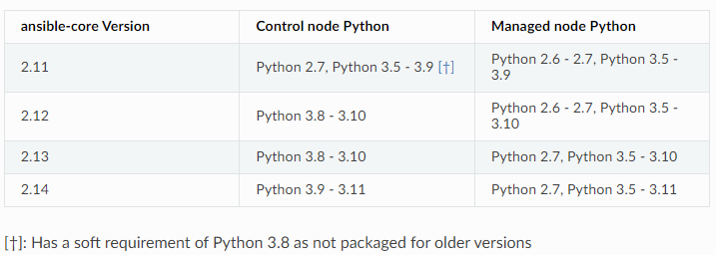

* **Ensuring pip is available**

To verify whether **pip** is already installed for your preferred Python:

$ python3 -m pip -V

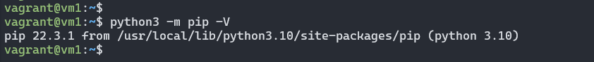

If you see an error like *No module named* *pip*, you’ll need to [install](https://pip.pypa.io/en/latest/installation/) **pip** under your chosen **Python** interpreter before proceeding. This may mean installing an additional OS package (for example, **python3-pip**), or installing the latest **pip** directly from the Python Packaging Authority by running the following:

$ curl [https://bootstrap.pypa.io/get-pip.py -o get-pip.py](https://bootstrap.pypa.io/get-pip.py%20-o%20get-pip.py)

$ python3 get-pip.py --user

* **Installing Ansible**

Use **pip** in your selected Python environment to install the Ansible package of your choice for the current user:

$ python3 -m pip install --user ansible

Alternately, you can install a specific version of ansible-core in this Python environment:

$ python3 -m pip install --user ansible-core==2.13.5

* **Upgrading Ansible**

To upgrade an existing Ansible installation in this Python environment to the latest released version, simply add **--upgrade** to the command above:

$ python3 -m pip install --upgrade --user ansible

* **Confirming your installation**

You can test that Ansible is installed correctly by checking the version:

$ ansible --version

To check the version of the ansible package that has been installed:

$ python3 -m pip show ansible

* [**Installing Ansible on specific operating systems**](https://docs.ansible.com/ansible/latest/installation_guide/installation_distros.html#installing-ansible-on-fedora-or-centos)

1. Install Installing Ansible on CentOs 7

$ sudo yum install epel-release

$ sudo yum install ansible

RPMs for currently supported versions of CentOS are also available from [**EPEL**](https://fedoraproject.org/wiki/EPEL)

1. Install Installing Ansible on Ubuntu

$ sudo apt update

$ sudo apt install software-properties-common

$ sudo add-apt-repository --yes --update ppa:ansible/ansible

$ sudo apt install ansible

* [**Amazon Linux**](https://www.ansiblepilot.com/articles/how-to-install-ansible-in-amazon-linux-2/)

1. Install Ansible on Amazon Linux2 using the Amazon Extras Library

$ sudo yum update -y

$ sudo amazon-linux-extras install ansible2 -y

$ ansible --version

1. Install Ansible on Amazon Linux2 using EPEL

$ sudo amazon-linux-extras install epel -y

$ sudo yum repolist

$ sudo yum-config-manager --enable epel

$ sudo amazon-linux-extras disable ansible2

$ sudo yum --enablerepo epel install ansible

$ ansible --version

1. Creating my first Ansible Control Node using Terraform.

* **Terraform file**

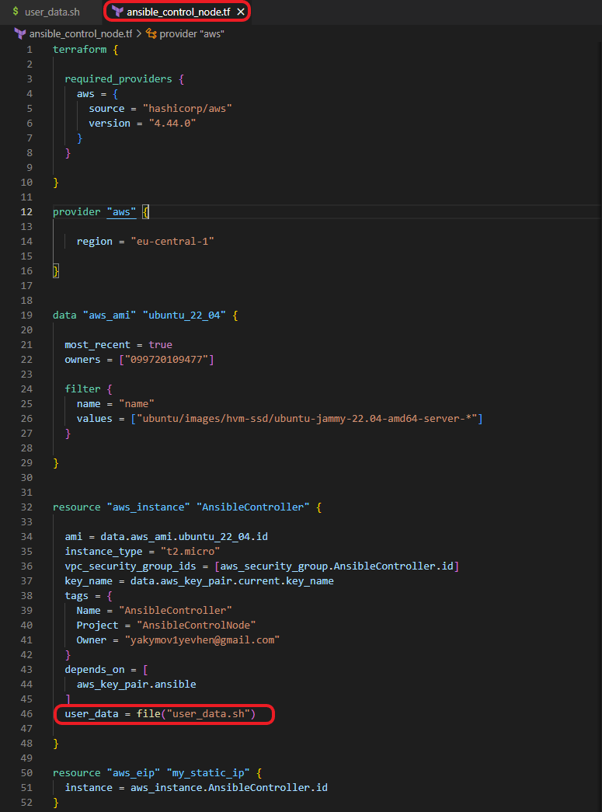

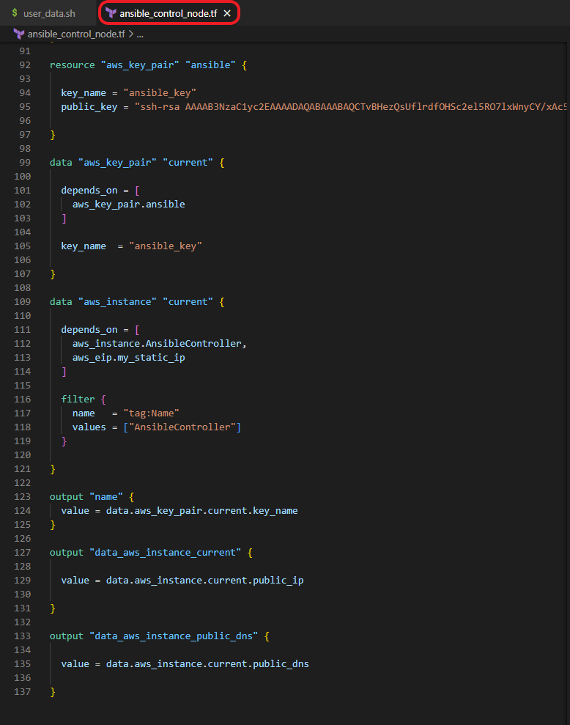

* **user_data.sh file**

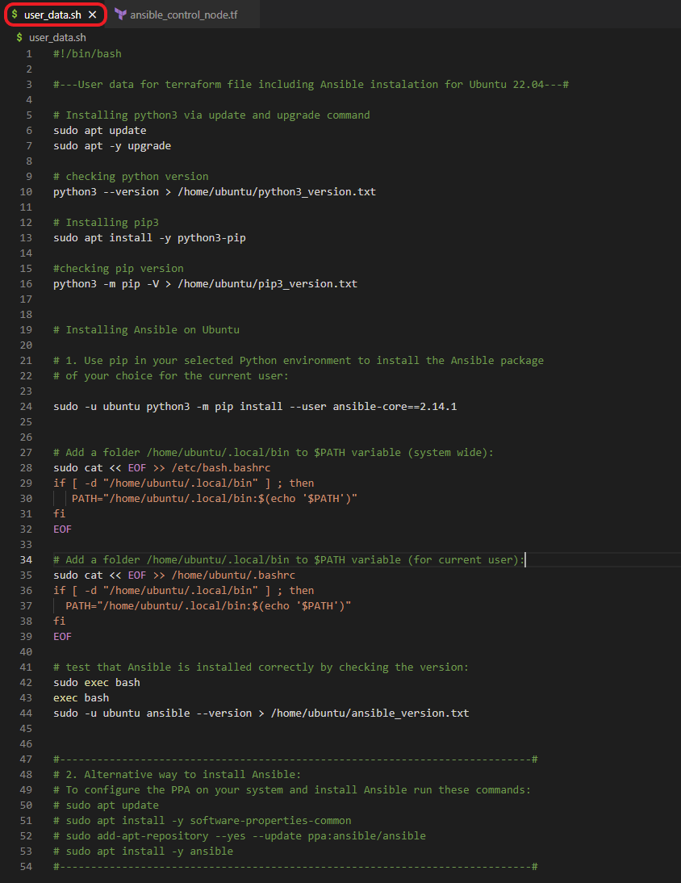

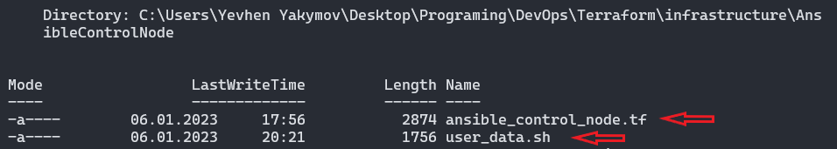

* **terraform plan, deploy and checking ansible version on AnsibleControlNode**

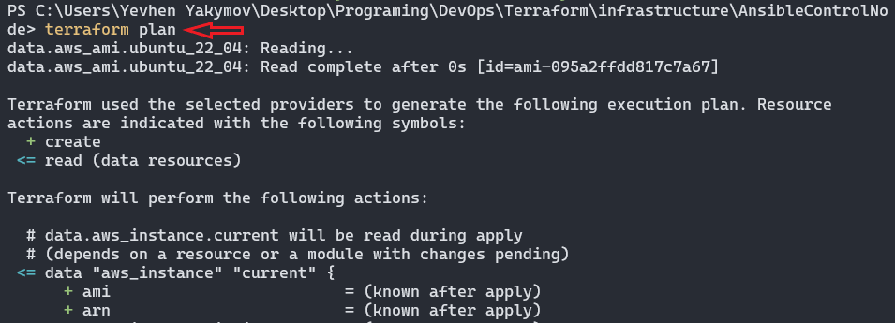

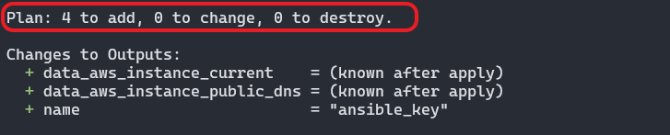

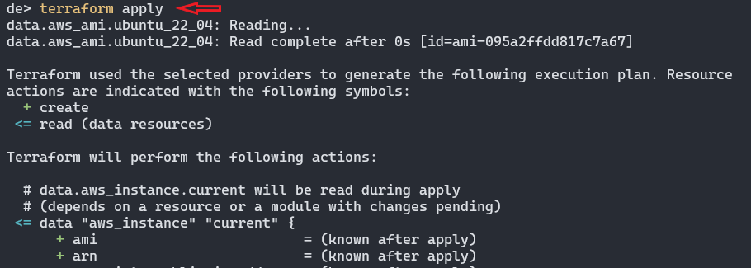

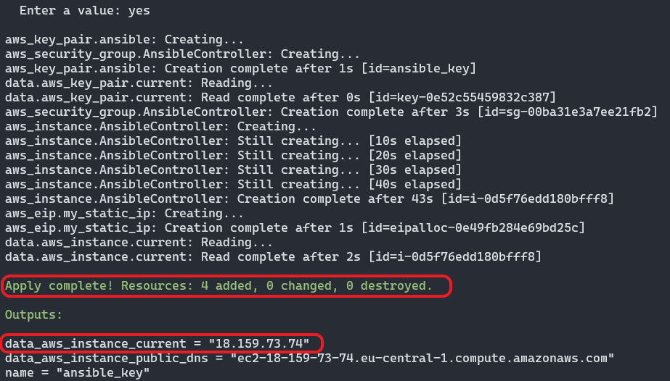

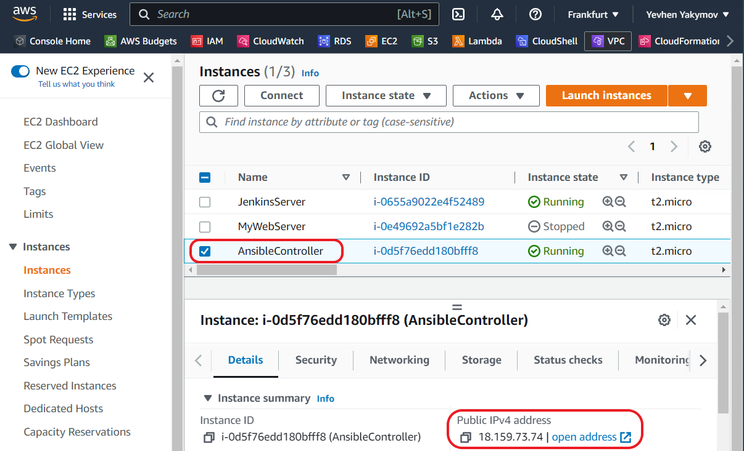

**ssh to our AnsibleController with MobaXterm using public IP and ansible_key**

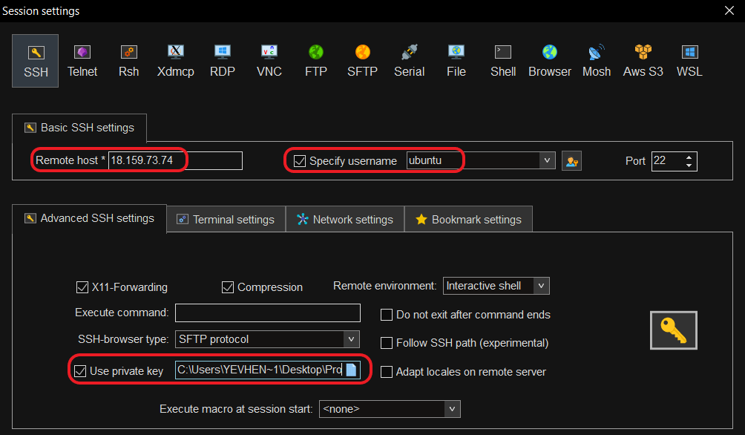

Checking **Ansible** version

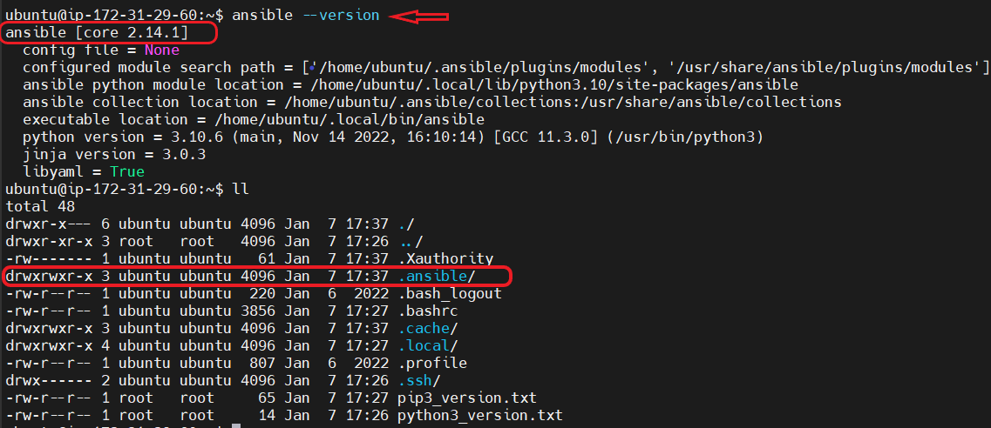

Checking **Python3 and pip** version

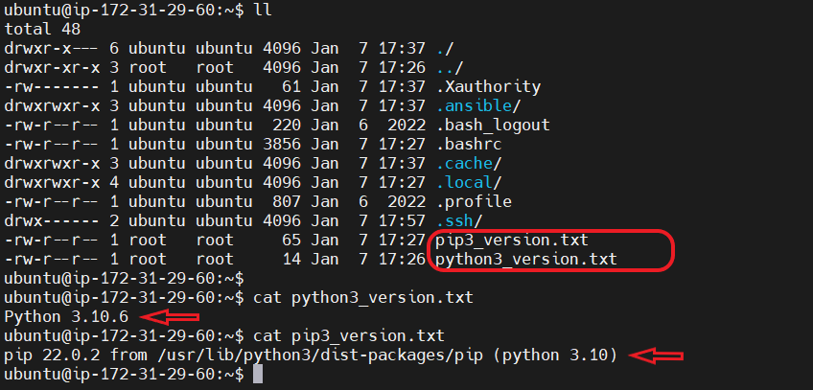

* **copy ansible_key to the AnsibleController**

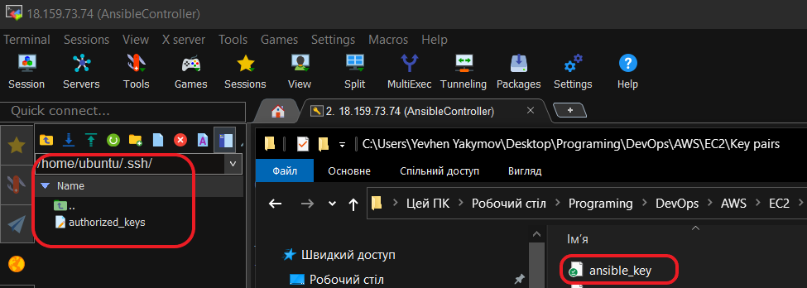

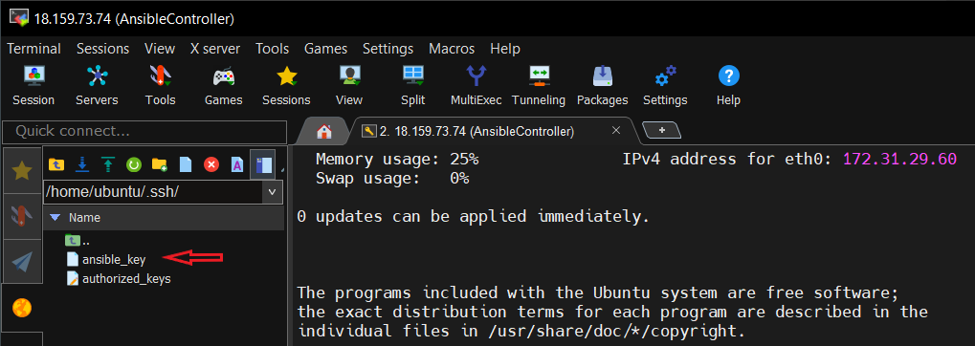

1. Creating my first’s Ansible Managed Node using Terraform.

* **Terraform file**

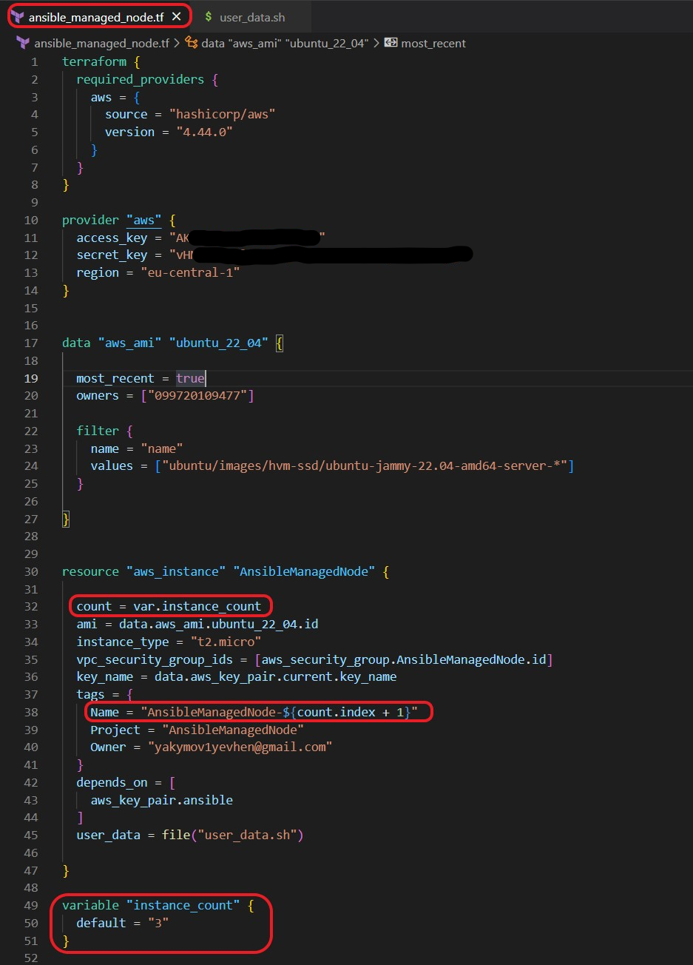

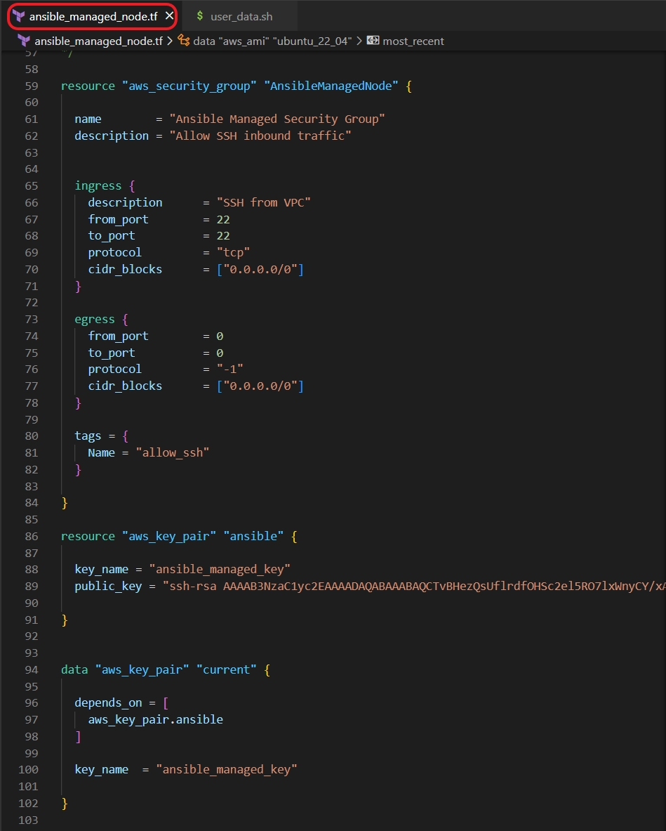

* **user_data.sh file**



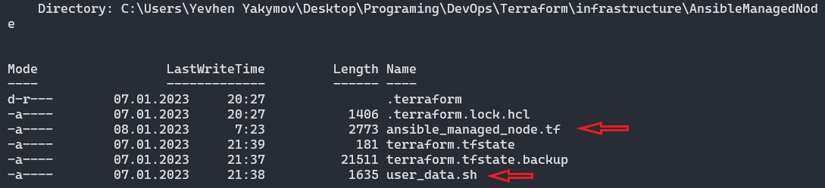

* **terraform plan, deploy and checking ansible version on AnsibleManagedNode**







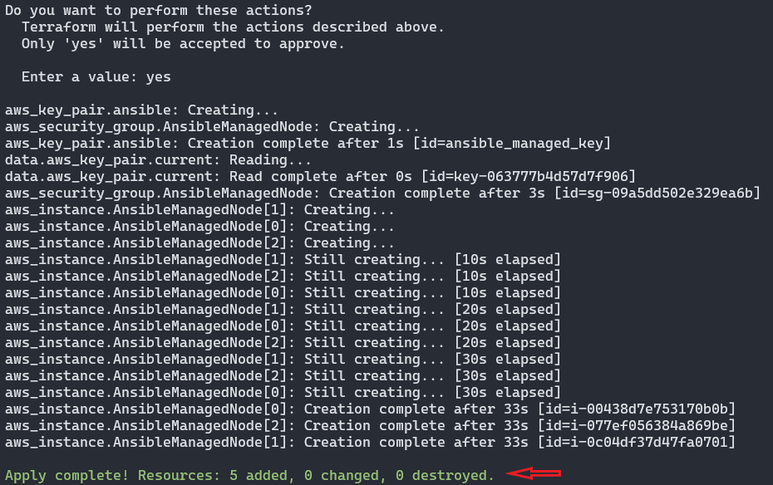

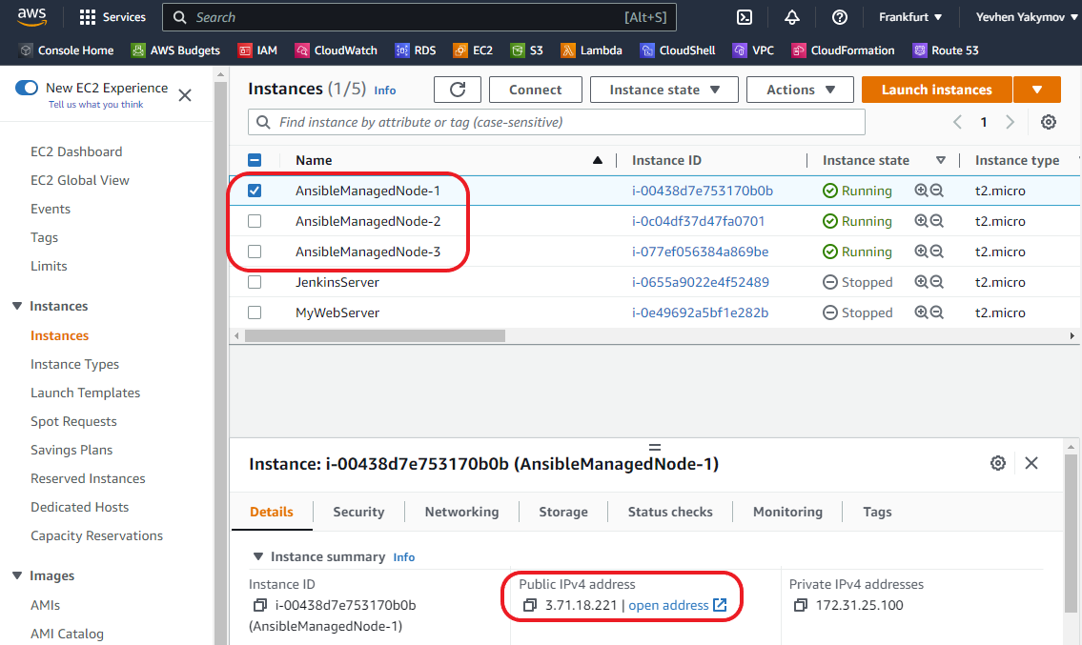

**ssh to our AnsibleManagedNode-1 with MobaXterm using public IP and ansible_key**

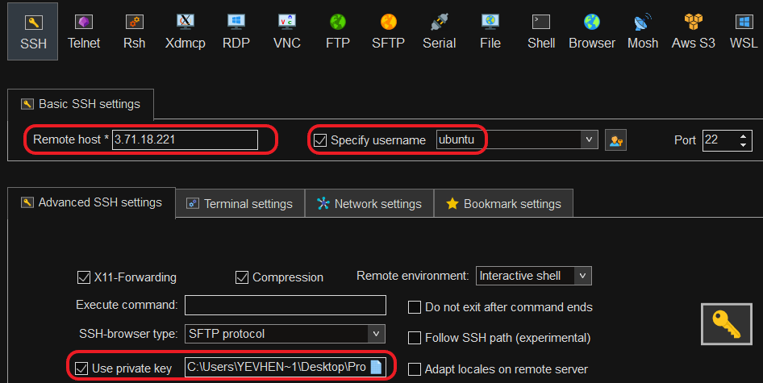

Checking **Ansible** version

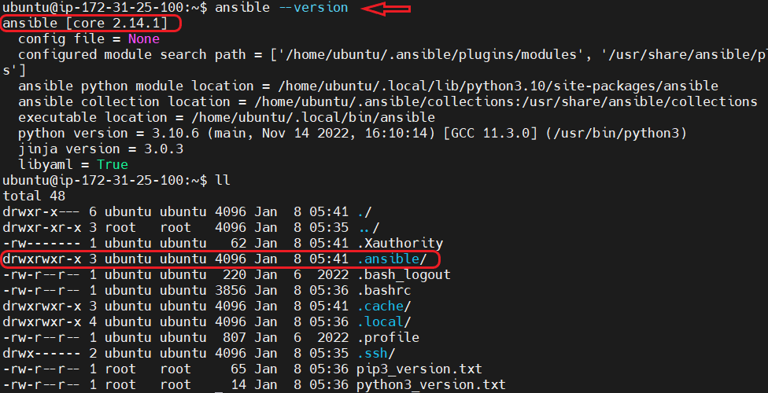

Checking **Python3 and pip** version

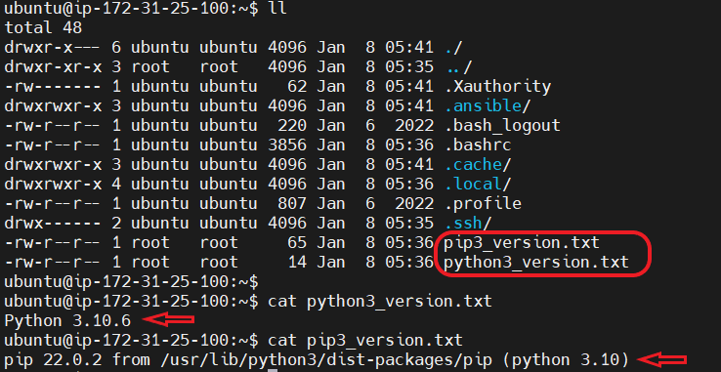

* **copy ansible_key.pub to the AnsibleManagedNode-1(2,3) ~/.ssh/authorized_keys**

**to have ability connect from AnsibleController to the AnsibleManagedNode-1(2,3)**

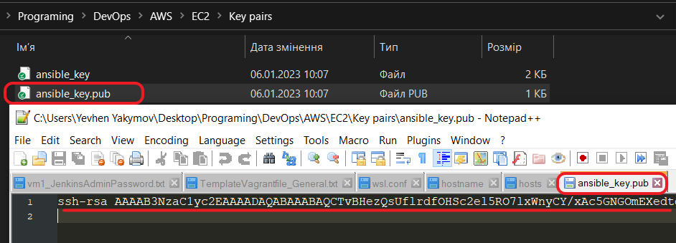

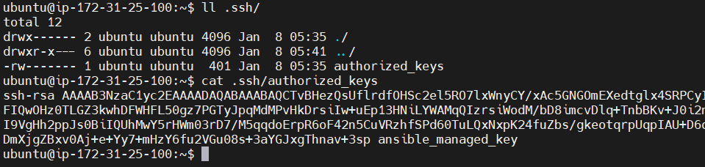

* **checking ssh connection from AnsibleController to the AnsibleManagedNode-1**

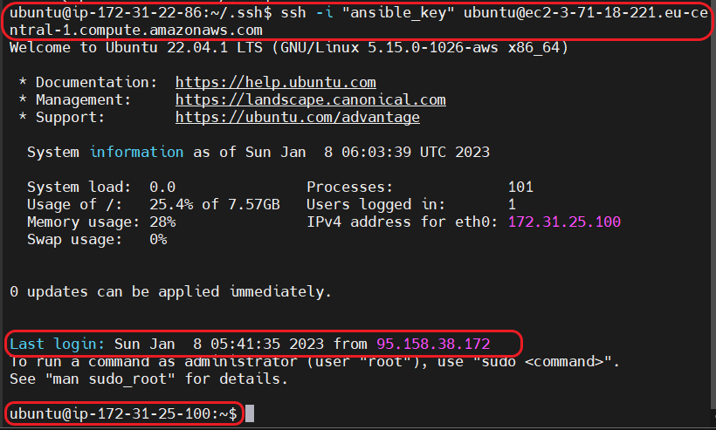



1. My first **Ansible** project **(inventory file**).

* Creation directory and file **hosts.txt(inventory file)** with description our managed node

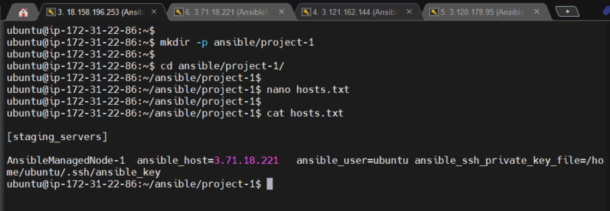

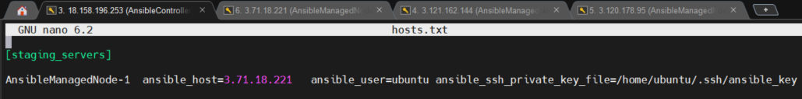

* Run first **ansible** command

$ ansible -i hosts.txt all -m ping

Where :

**- i** – option specify inventory host path or comma separated host list

**hosts.txt** – inventory file

**all** - apply for all servers described in the inventory file

**-m** – name of the action to execute

**ping** – module name

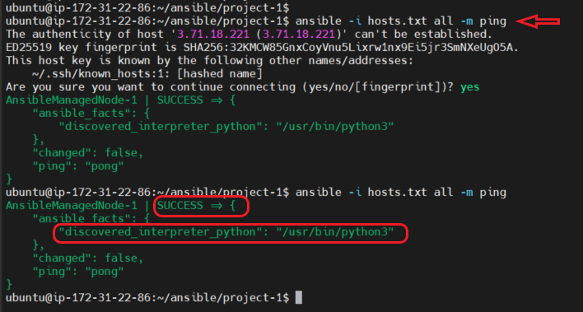

1. My second **Ansible** project.

* Creation project directory, file **hosts.txt(inventory)** with description our managed node’s

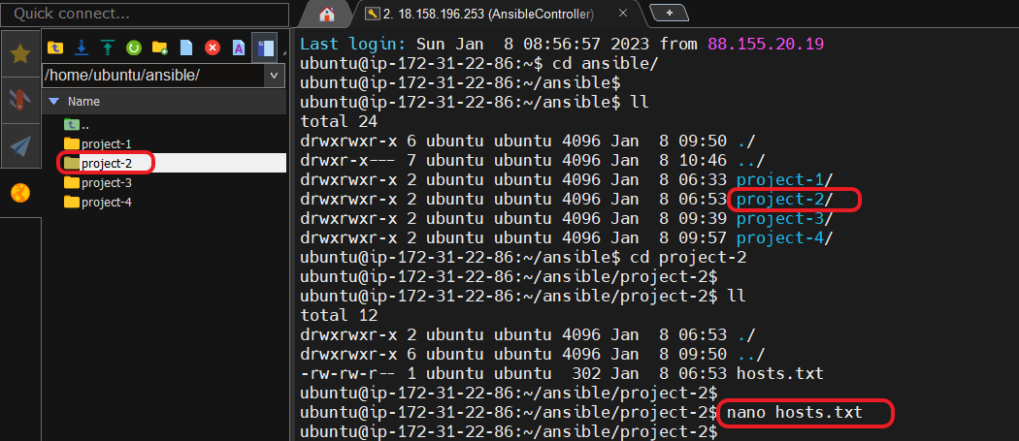

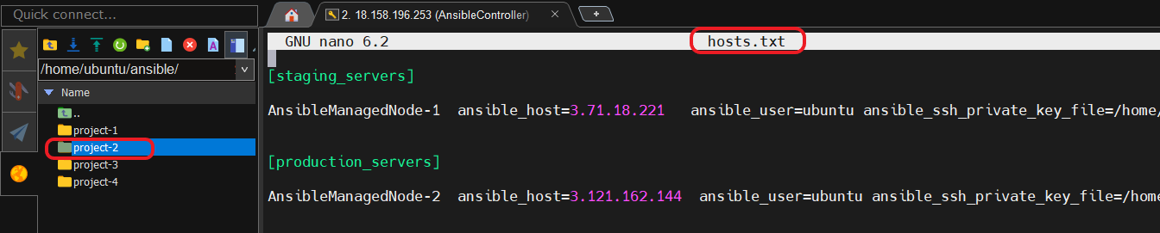

* Run **ansible** command

$ ansible -i hosts.txt all -m ping

Where :

**- i** – option specify inventory host path or comma separated host list

**hosts.txt** – inventory file

**all** - apply for all servers described in the inventory file

**-m** – name of the action(module) to execute

**ping** – module name

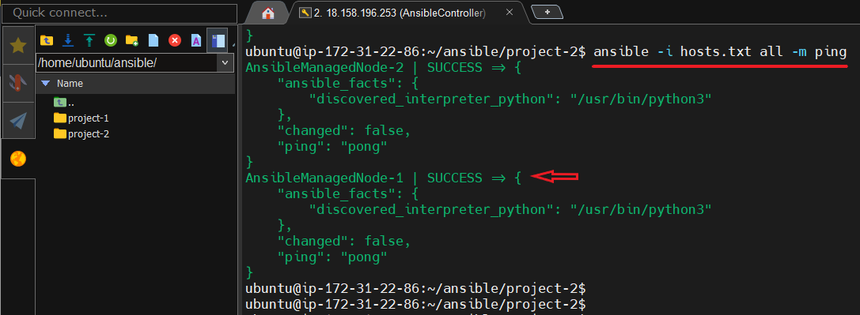

1. My third **Ansible** project (**ansible.cfg**) .

* Creation project directory, file **hosts.txt** with description our managed node’s and **ansible.cfg** file with **host_key_checking**, **inventory** parametrs.

Where :

**host_key_checking** - set this to “False” if you want to avoid host key checking by the underlying tools Ansible uses to connect to the host.

**inventory** – relative path to the inventory file.

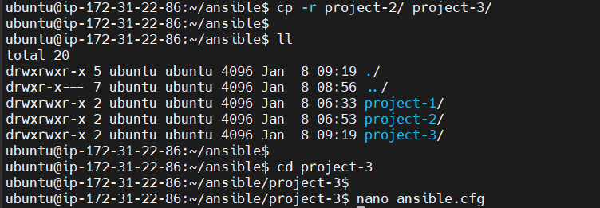

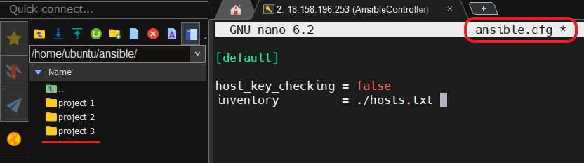

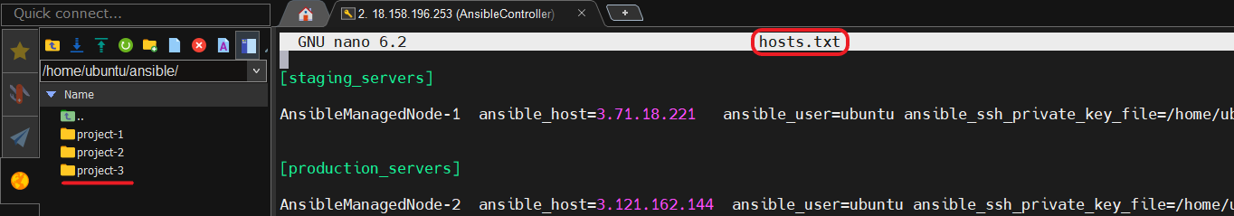

* Run **ansible** command without **-i** option and specifying **inventory file**

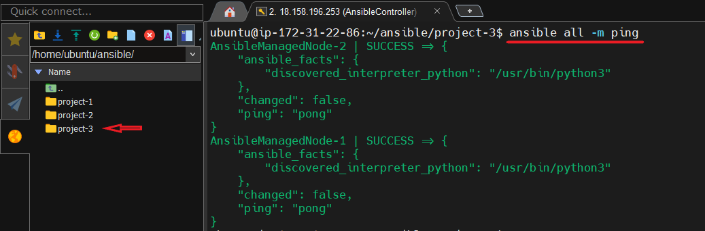

1. My fourth **Ansible** project.

* Creation project directory, file **hosts.txt** with description our managed node’s and **ansible.cfg** file with **host_key_checking**, **inventory** parametrs.

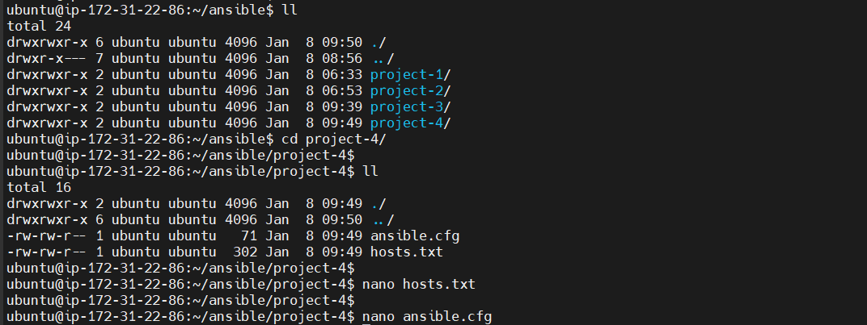

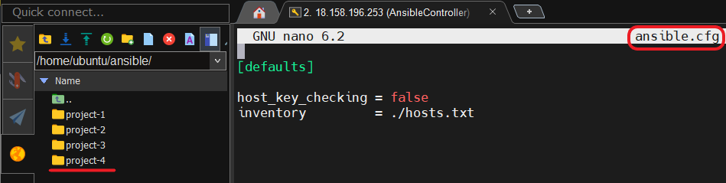

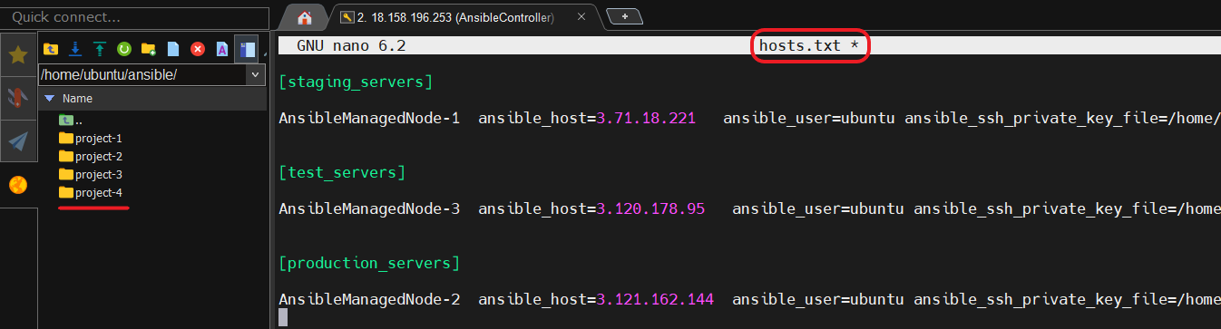

* Run **ansible** command without **-i** option and specifying **inventory file**

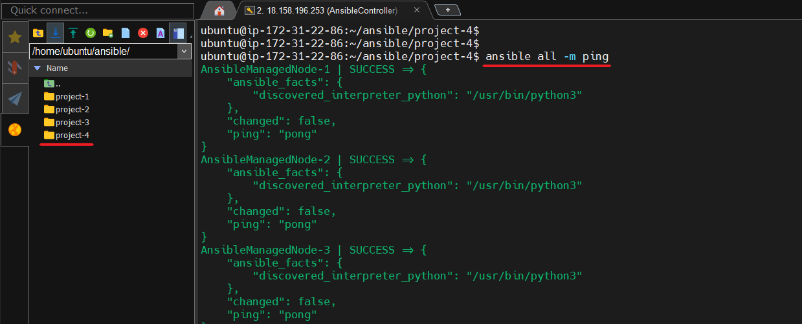

1. My fifth **Ansible** project (**vars, children**).

* Creation project directory, file **hosts.txt** with description our managed node’s using **vars**, **children** parametrs and **ansible.cfg** file with **host_key_checking**, **inventory** parametrs.

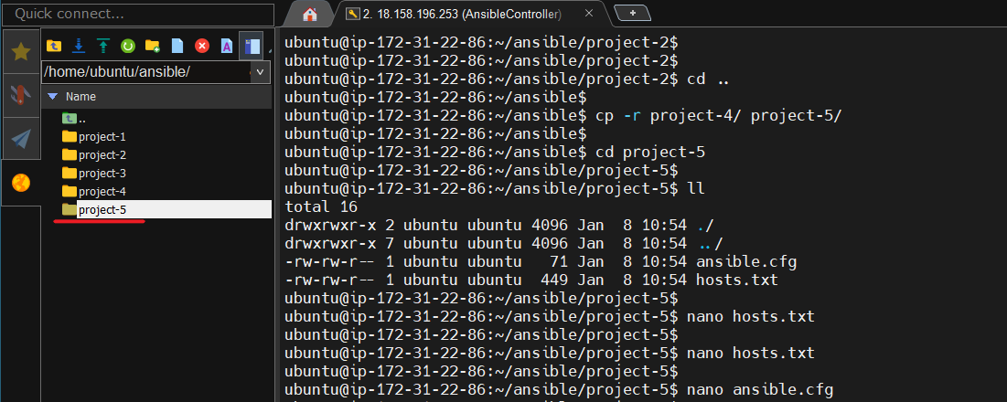

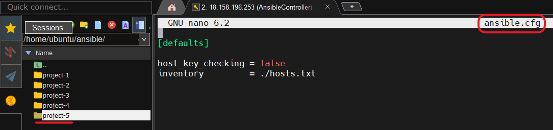

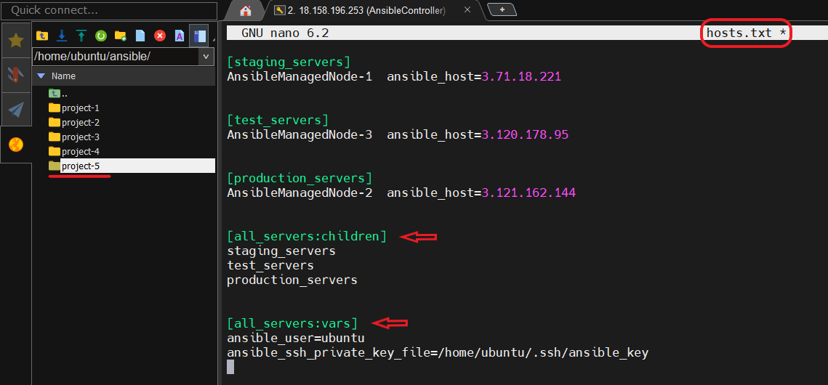

* Run **ansible** command without **-i** option and specifying **inventory file**

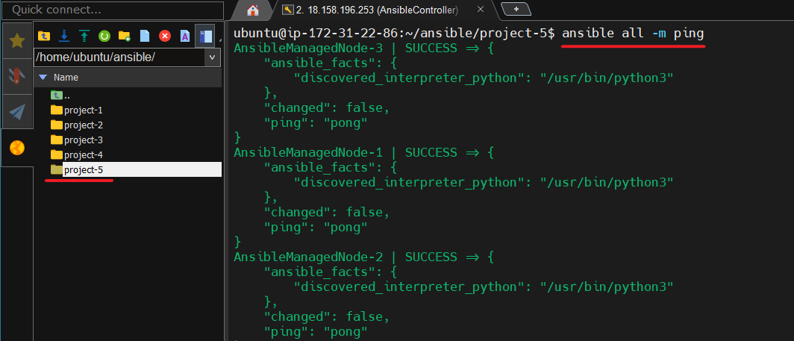

* Run **ansible** commands that show **list** and **graph** based on the **inventory file**

$ ansible-inventory --list

$ ansible-inventory --graph

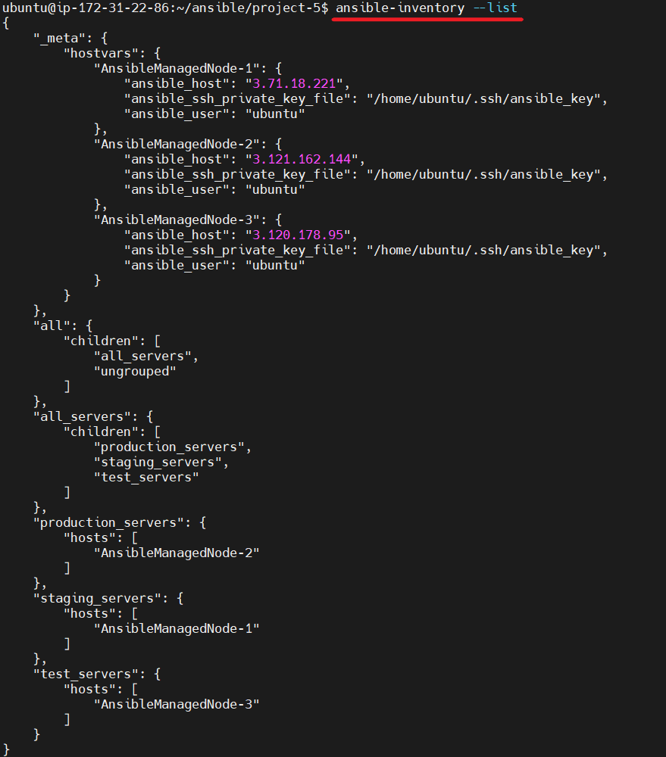

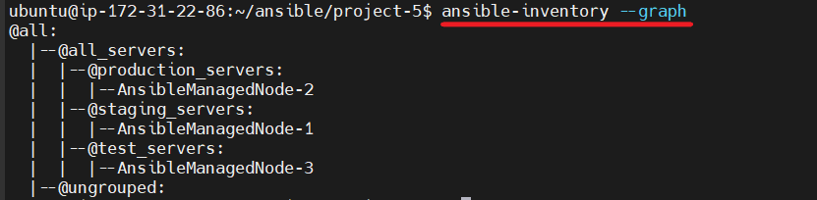

* Run **ansible** command with **setup** module.

$ ansible staging_servers -m setup

Where :

**staging_servers** – name of the grouped servers from the inventory file.

**setup** – module that outputs information about Ansible Managed Node’s .

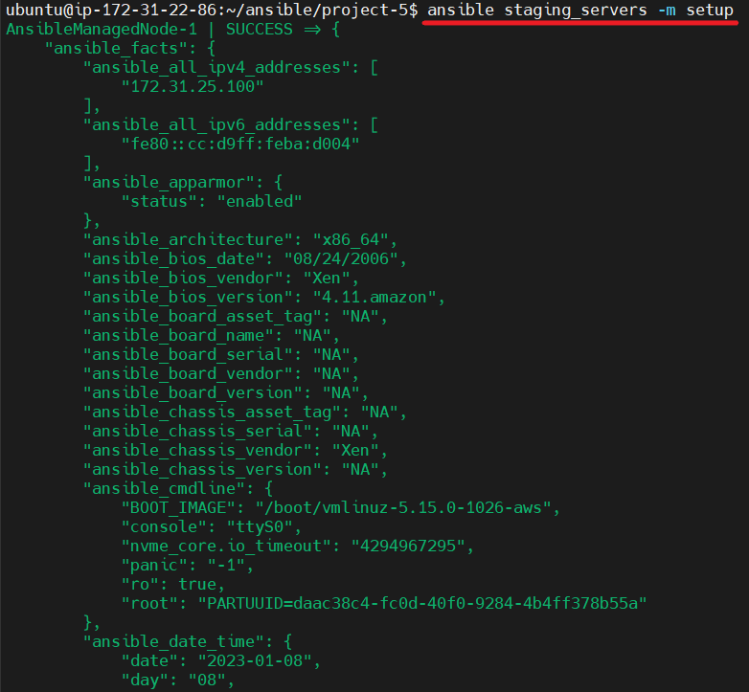

* Run **ansible** command with **shell** module and **uptime** argument.

$ ansible all -m shell -a "uptime"

Where :

**all** – for all servers from the inventory file.

**shell** – a module that runs the shell on all servers.

“**uptime”** – an argument: command that is executed in shells on each servers group all

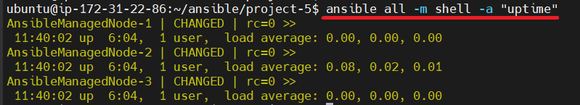

* Run **ansible** command that copies the file to all Ansible Managed Node’s.

$ echo “Hello World!” > hello.txt

$ ansible all -m copy -a "src=hello.txt dest=/home" -b

Where :

**all** – for all servers from the inventory file.

**copy** – a module that copies file from Ansible Control to the Ansible Managed Node’s.

**“src”** – an argument: the relative path to the file hello.txt on the Ansible Control Node

**“dest”** – an argument: absolute path on the Managed Node where hello.txt must be copied

**“-b”** – an option: run operations as this user (default=root)

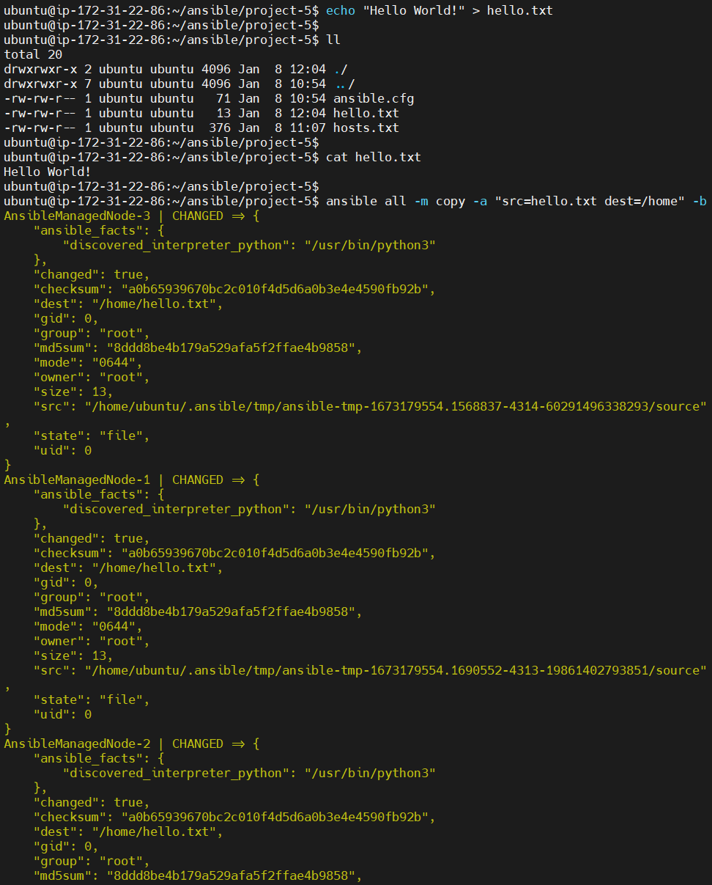

* Run **ansible** command that checking copy command from previous point.

$ ansible all -m shell -a "ls -la /home" -b

Where :

**all** – for all servers from the inventory file.

**shell** – module that runs the shell on all servers.

**“ls -la /home”** – argument:output the content **/home** on the Ansible Managed Node

**“-b”** – option: run operations as this user (default=root)

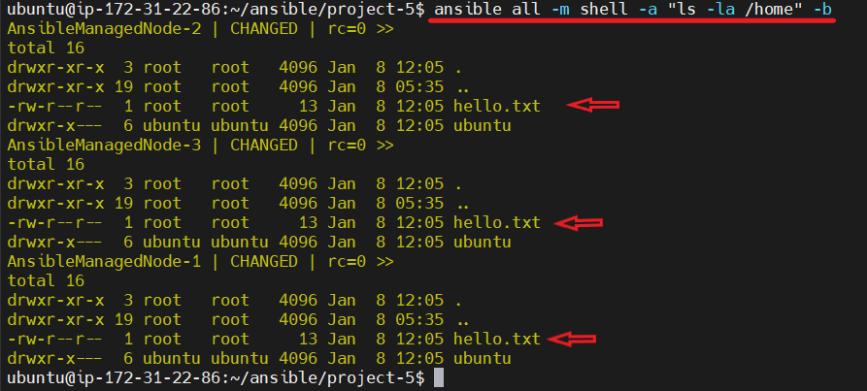

* Run **ansible** command that delete hello.txt file from Ansible managed Node’s.

$ ansible all -m file -a "path=/home/hello.txt state=absent" -b

Where :

**file** – module that manage files and file properties.

**“path”** – argument: path to the file being managed on the Ansible Managed Node

**“state”** – argument: if absent, directories will be recursively deleted.

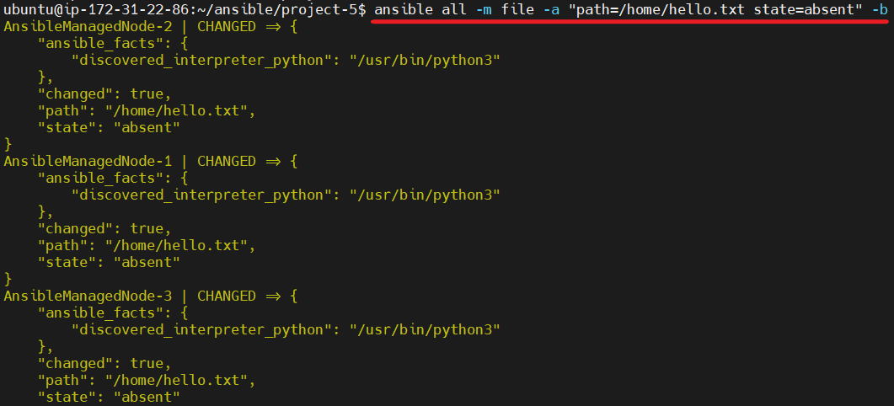

* Run **ansible** command that install Apache Web Server on the Ansible Managed Node’s.

$ ansible production_servers -m apt -a "name=apache2 state=latest" -b

Where :

**apt** – module that manages apt packages (such as for Debian/Ubuntu).

**“name”** – argument: a list of package names.

**“state”** – argument: indicates the desired package state. *latest* ensures that the latest version is installed.

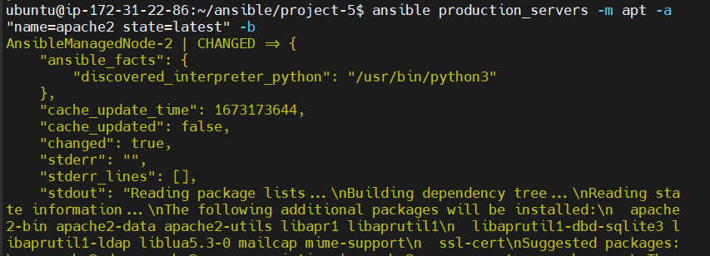

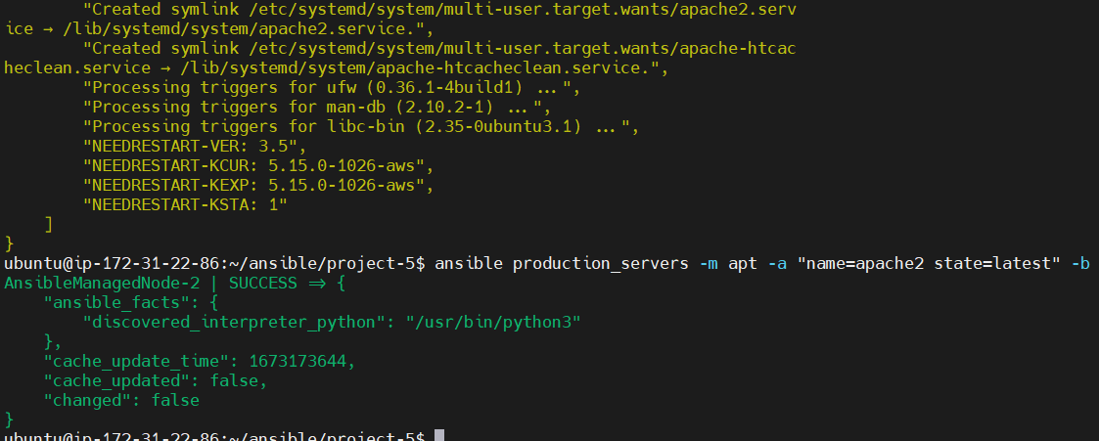

* Run **ansible** command that start and enable Apache Web Server on the Ansible Managed.

$ ansible production_servers -m service -a "name=apache2 state=started enabled=yes" -b

Where :

**service** – module controls services on remote hosts.

**“name”** – argument: a list of package names.

**“state”** – argument: started/stopped are idempotent actions that will not run commands unless necessary. At least one of state and enabled are required

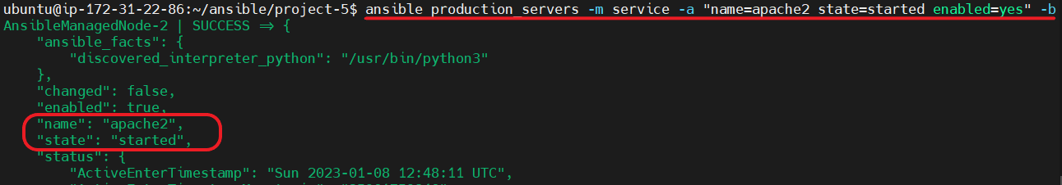

* Checking that our Apache Web Server is running.

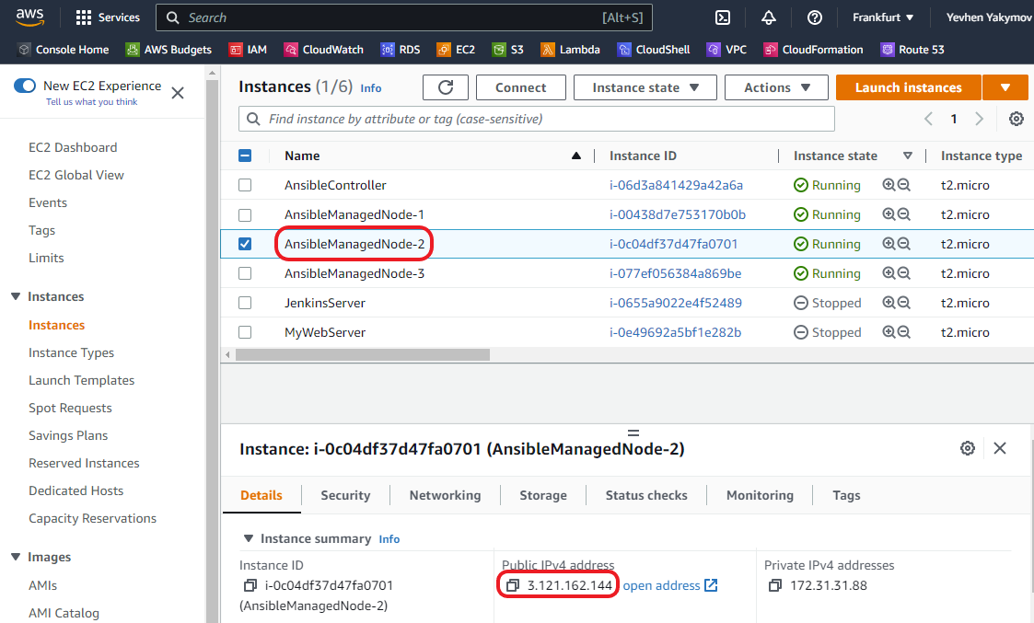

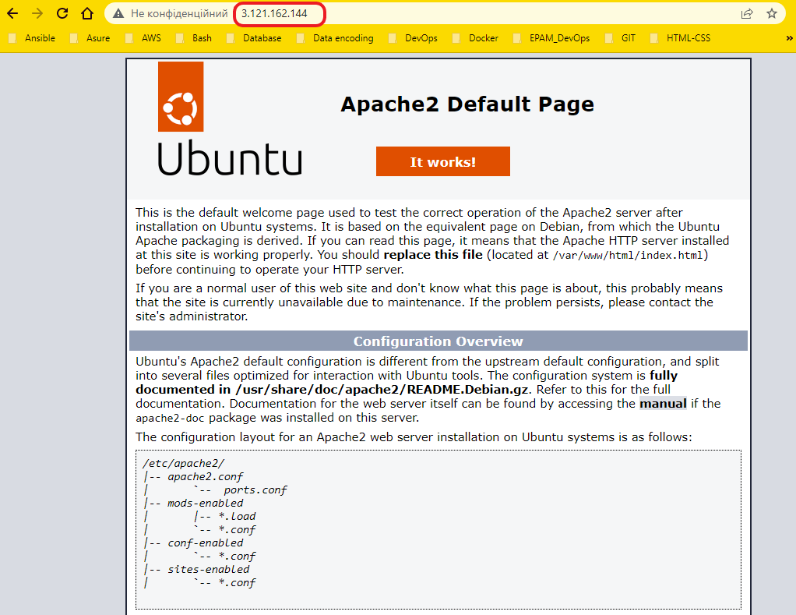

* Remove Apache Web Server from Ansible Managed Node.

$ ansible production_servers -m apt -a "name=apache2 state=absent" -b

Where :

**apt** – module that manages apt packages (such as for Debian/Ubuntu).

**“name”** – argument: a list of package names.

**“state”** – argument: *absent* will remove the specified package.

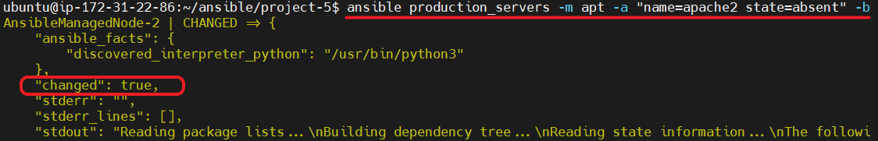

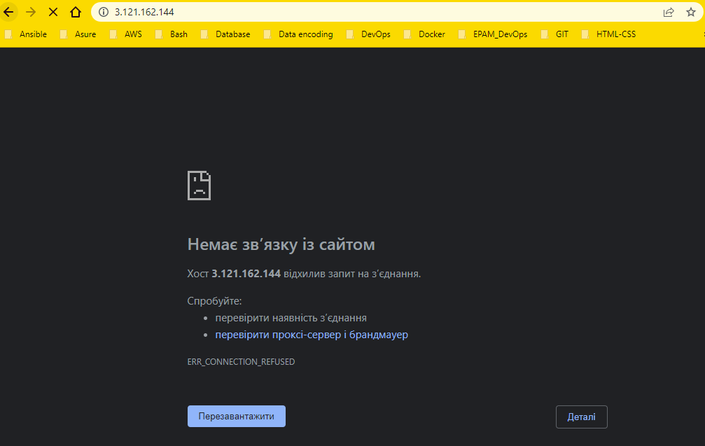

1. My first **Ansible** playbook.

**Task: Test connection to all servers, owned by your organization.**

* Creation first **playbook1.yml**

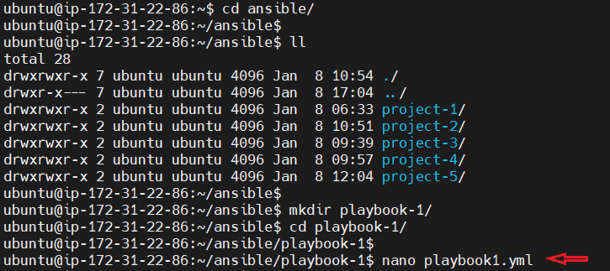

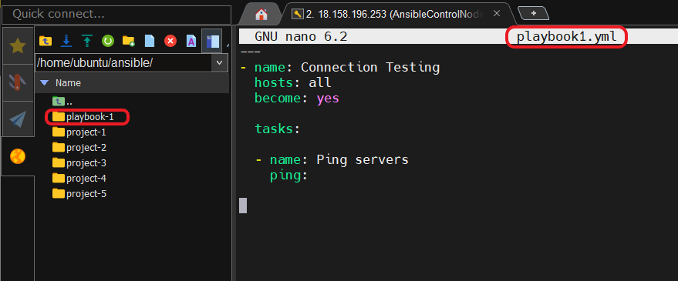

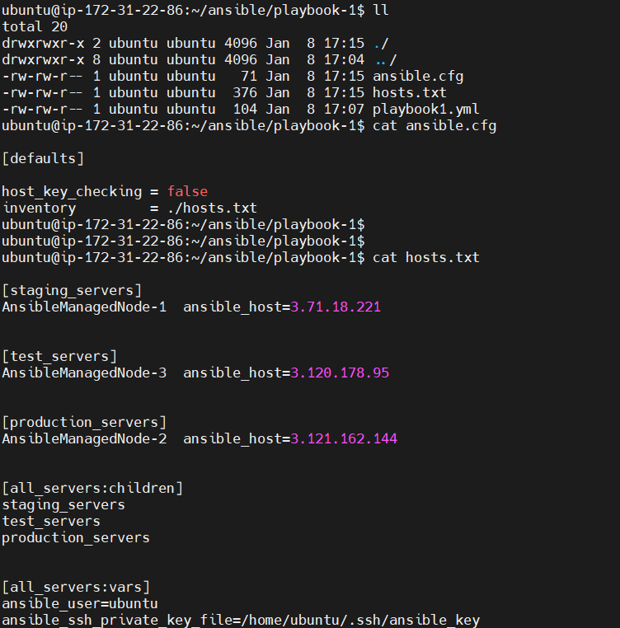

* Run **ansible-playbook** command.

$ ansible-playbook playbook1.yml

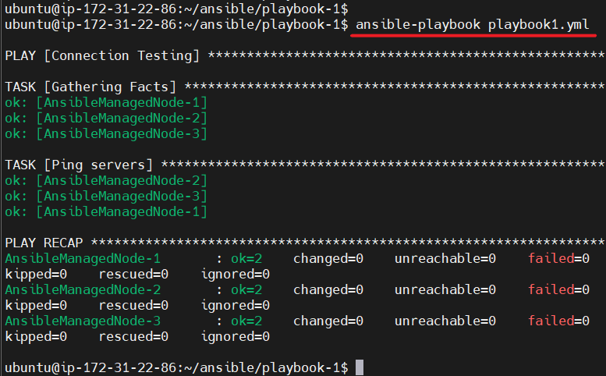

1. My second **Ansible** playbook.

**Task: Install Apache Web Server on all servers, owned by your organization. Also needed to start Apache Web Server and enable it during boot.**

* Creation project directory, file **hosts.txt** with description our managed node’s and **ansible.cfg** file with **host_key_checking**, **inventory** parametrs and **playbook2.yml** with Apache Web Server instalation.

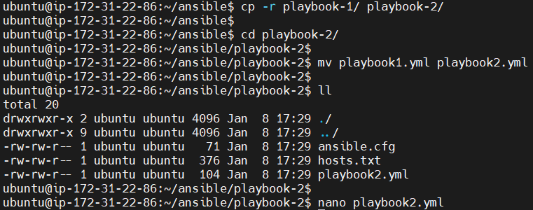

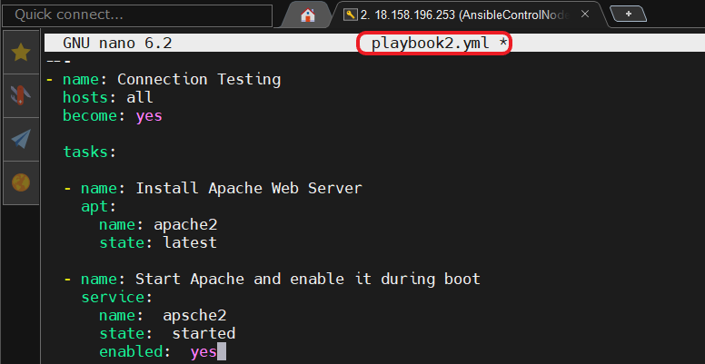

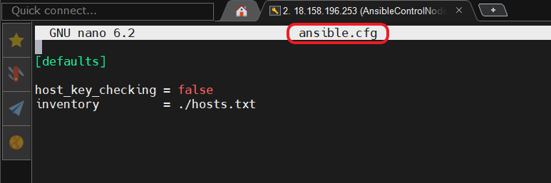

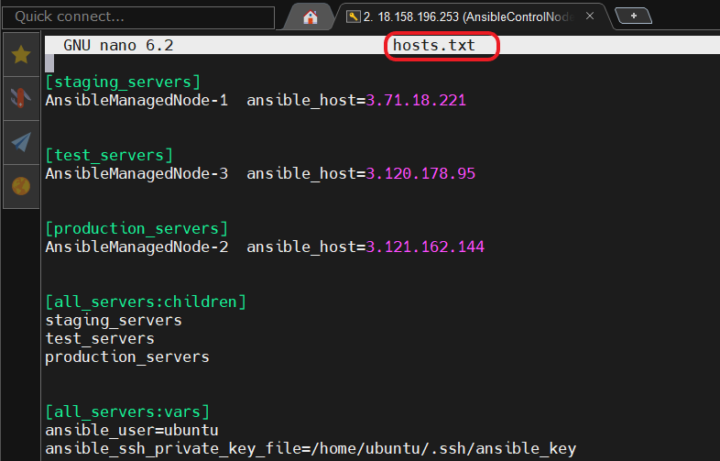

* Run **ansible-playbook** command.

$ ansible-playbook playbook2.yml

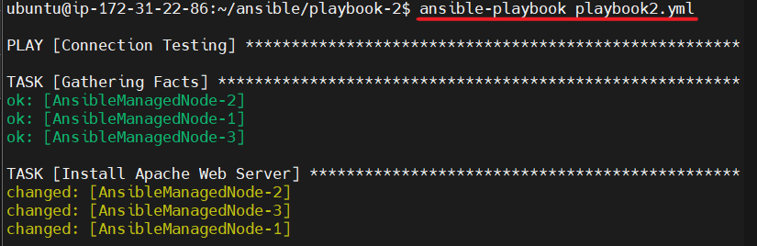

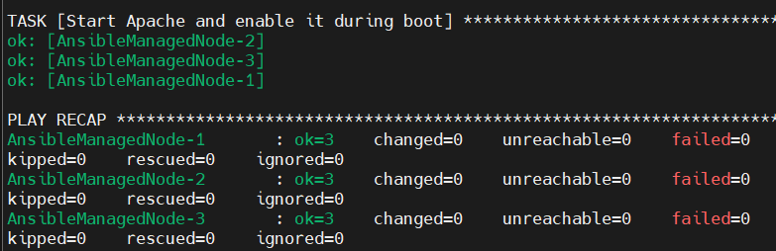

* Checking the availability of the Apache 2 default page on all Ansible Managed Node’s.

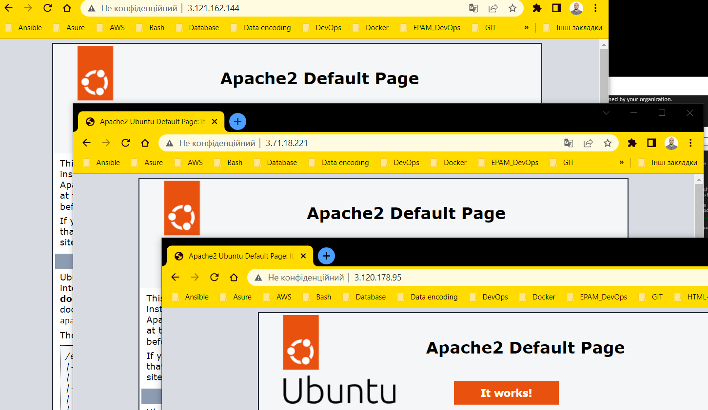

1. My third **Ansible** playbook.

**Task: Install Apache Web Server on all servers, owned by your organization. Also needed to start Apache Web Server and enable it during boot. Also needed to change default index.html**

* Creation **playbook3.yml** with Apache Web Server instalation and copying **index.html**.

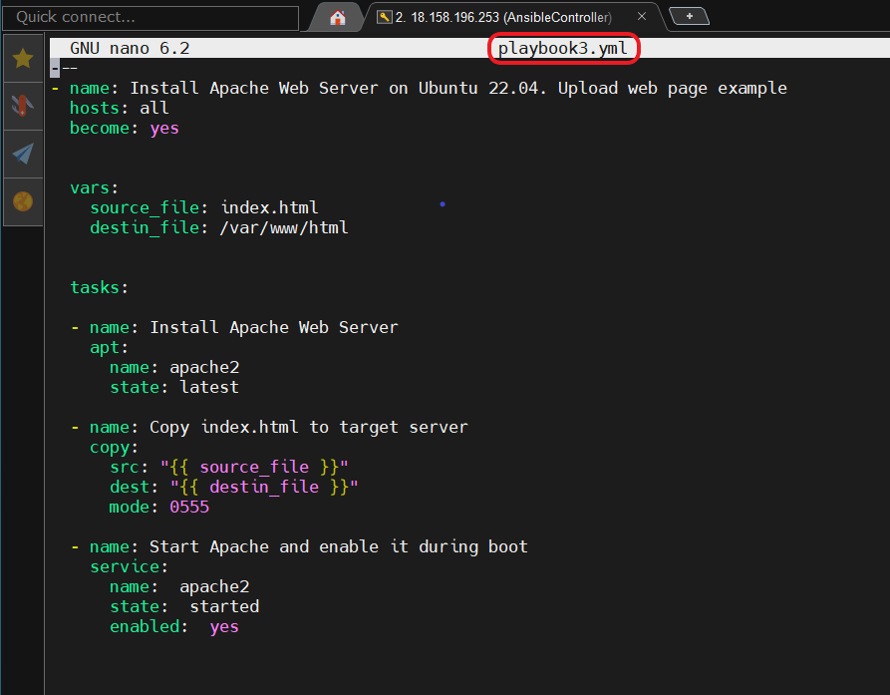

* Creation **index.html** file.

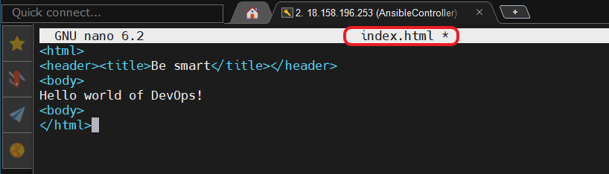

* Working directoryof the project **playbook-3**.

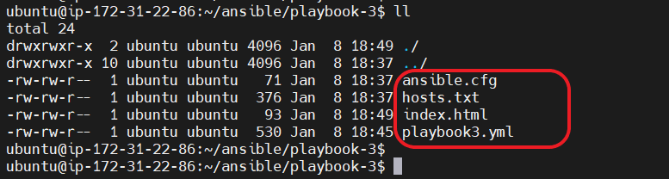

* Run **ansible-playbook** command.

$ ansible-playbook playbook3.yml

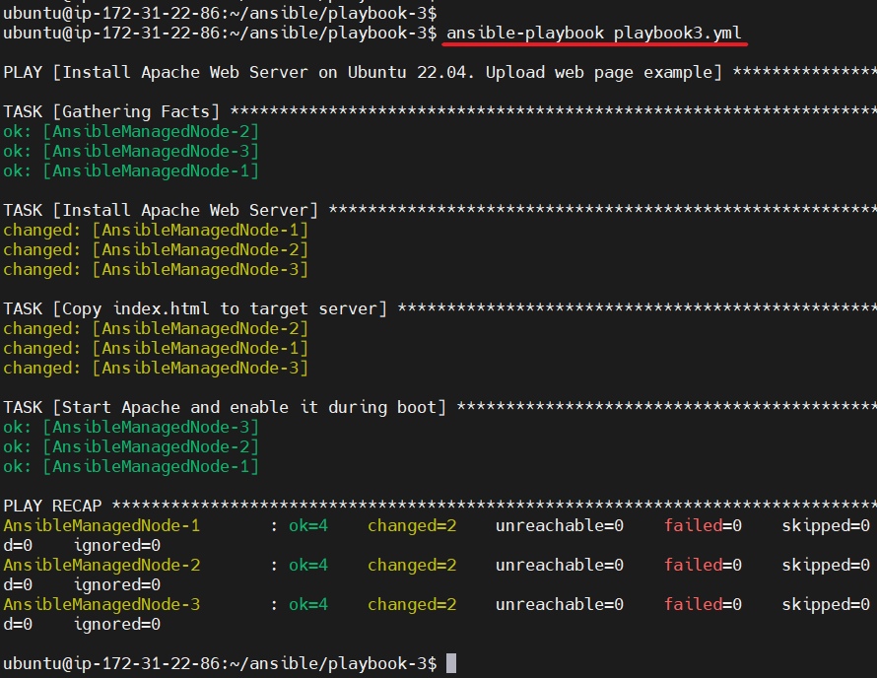

* Checking the availability of the **index.html** page on all Ansible Managed Node’s.

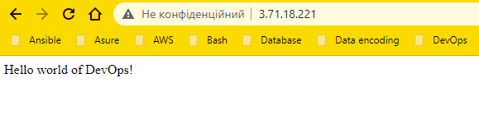

* Restart **Apache** after copying **index.html** to the Ansible Managed Node’s using **notify** and **handlers**.

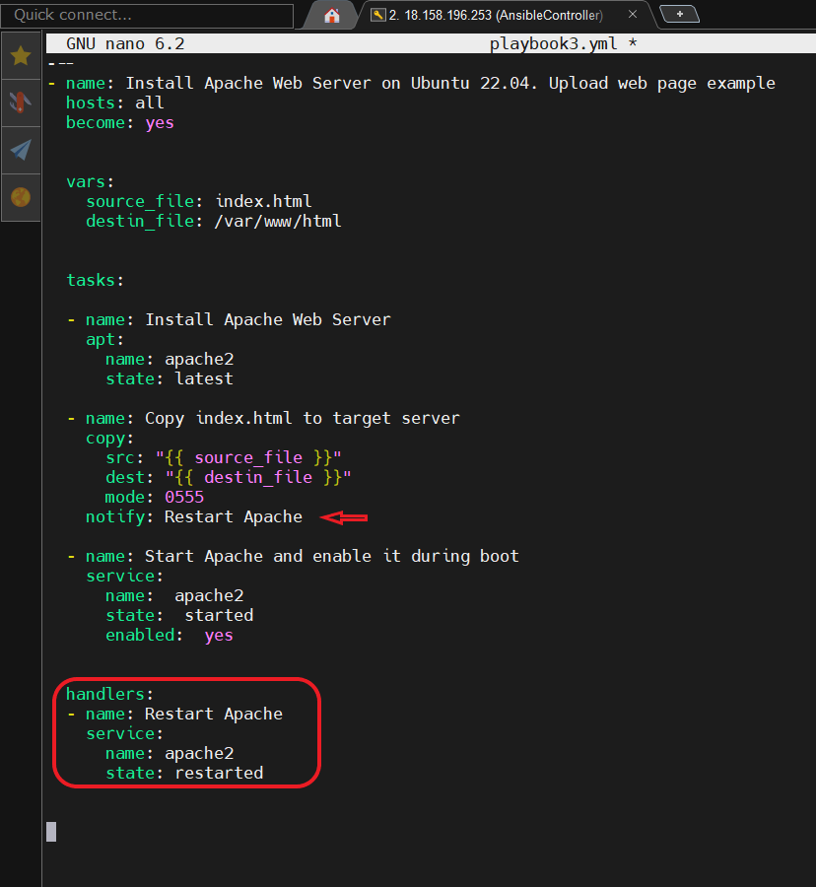

* Changing **index.html** file.

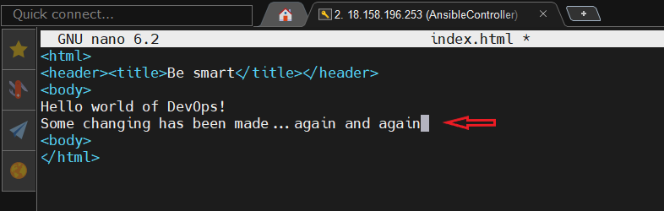

* Run **ansible-playbook** command.

$ ansible-playbook playbook3.yml

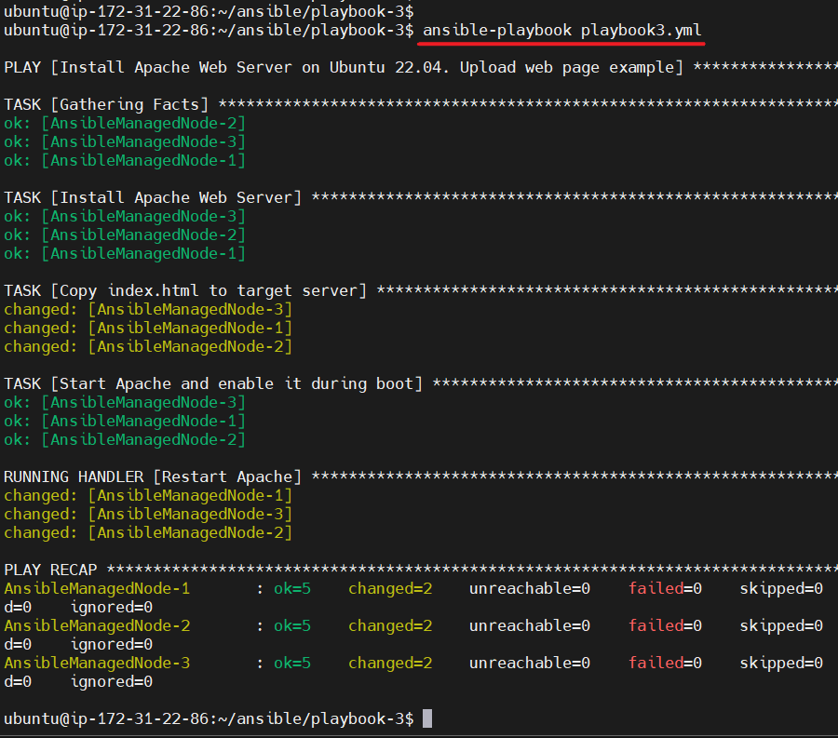

* Checking the availability of the **index.html** page on all Ansible Managed Node’s.

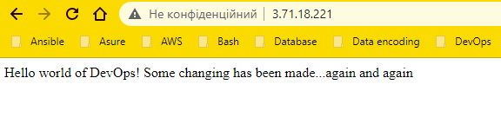

1. My fourth **Ansible** playbook.

**Task: Install Apache Web Server on all servers, owned by your organization. Also needed to start Apache Web Server and enable it during boot. Also needed to change default index.html. Servers are on different Linux-based OS( Amazon Linux and Ubuntu).**

* Creation files **playbook4.yml, hosts.txt, group_vars/ami_cred, group_vars/deb_cred, ansible.cfg**

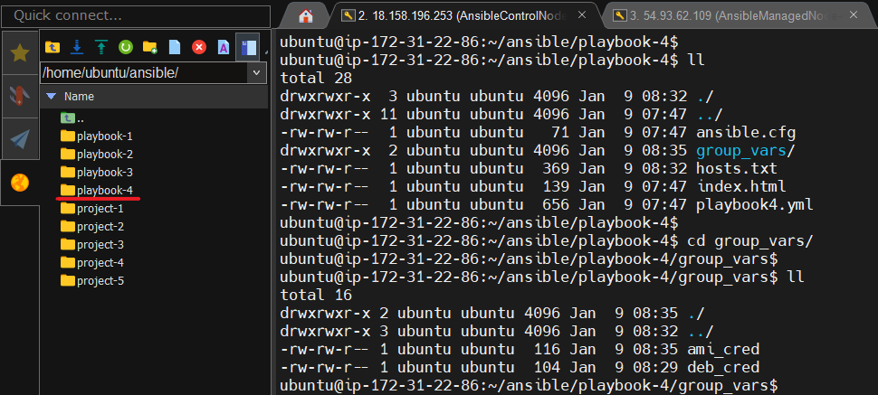

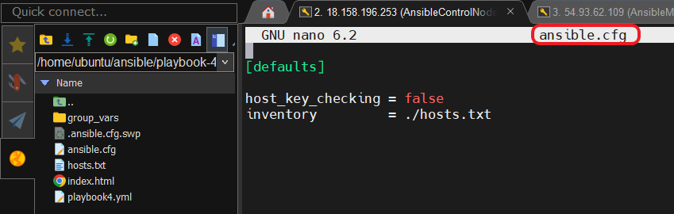

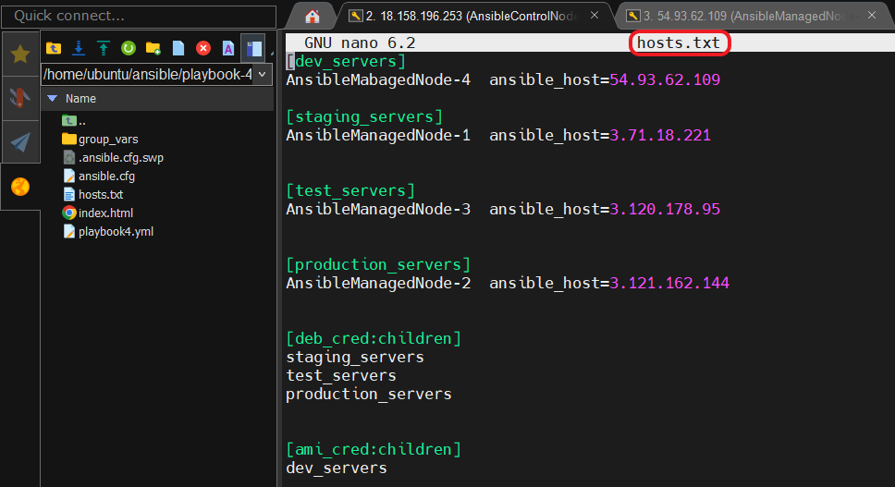

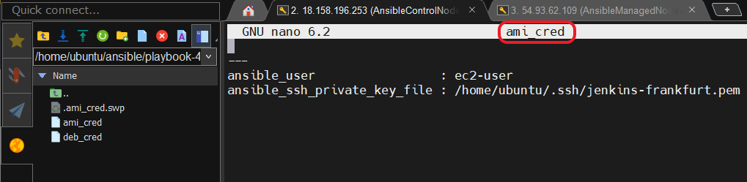

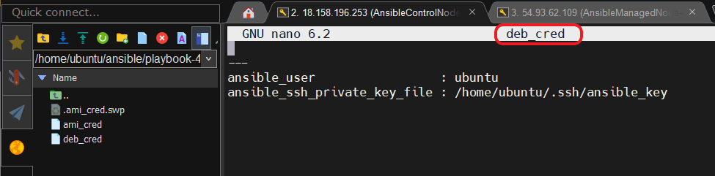

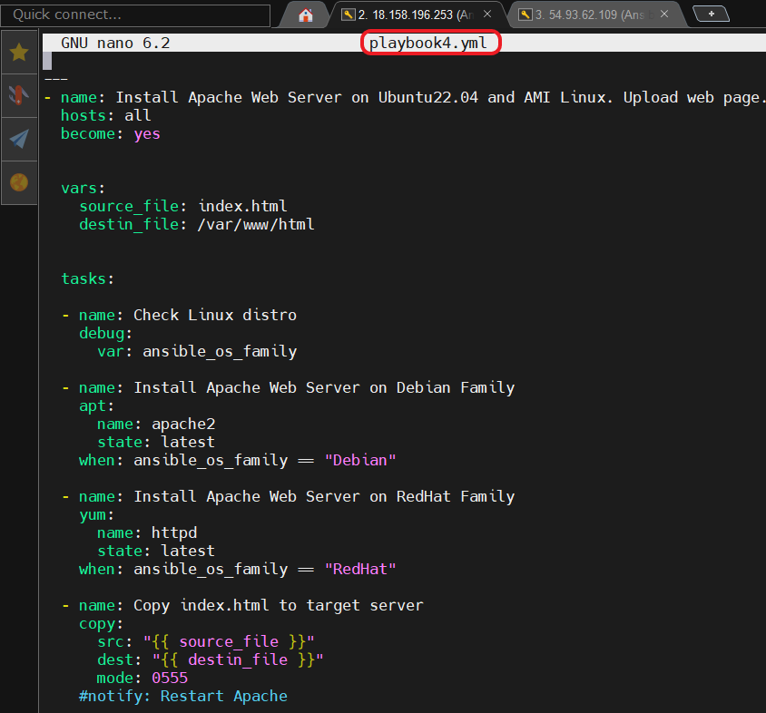

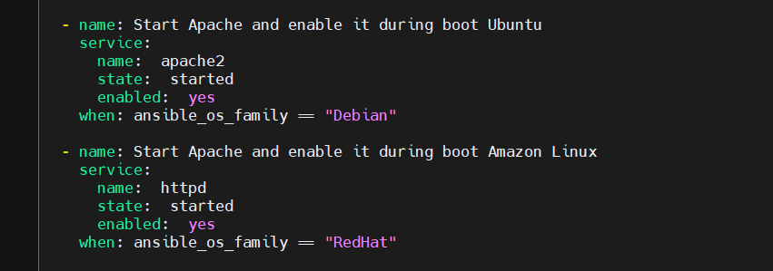

* Run **ansible-playbook** command.

$ ansible-playbook playbook4.yml

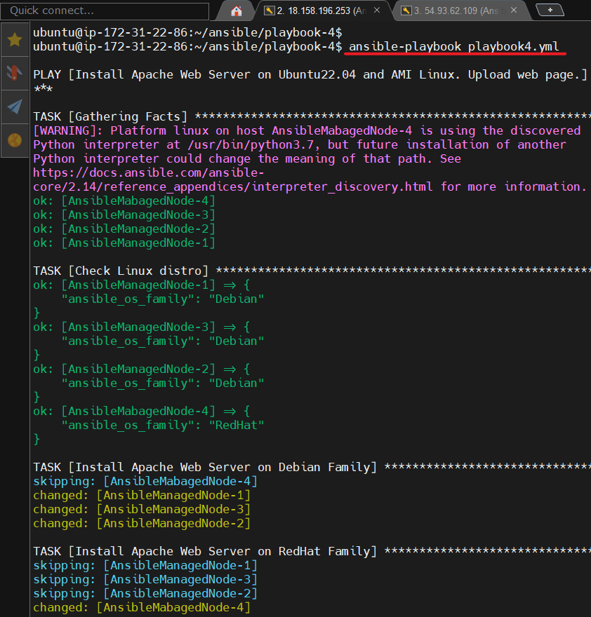

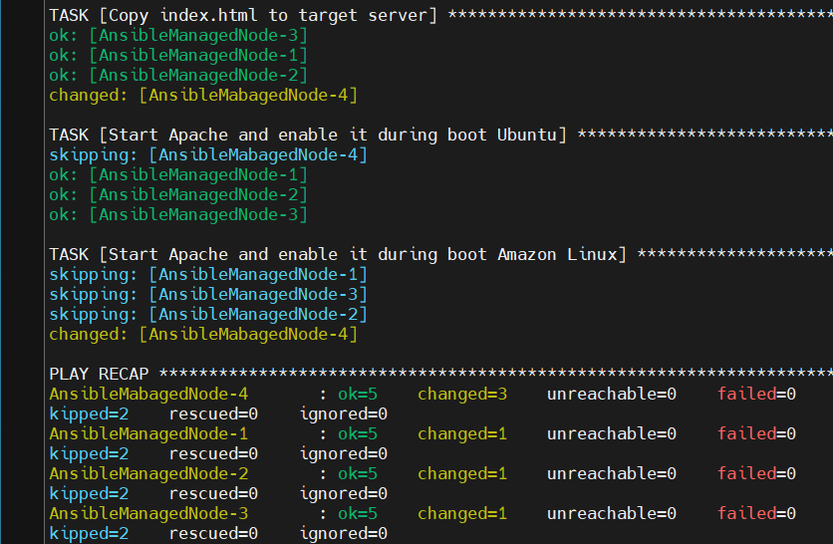

1. My fifth **Ansible** playbook.

**Task: Install Apache Web Server on all servers, owned by your organization. Also needed to start Apache Web Server and enable it during boot. Also needed to change default index.html. Servers are on different Linux-based OS( Amazon Linux and Ubuntu).**

* Creation file **playbook5.yml** with using blocks parametr **(** files **hosts.txt, group_vars/ami_cred, group_vars/deb_cred, ansible.cfg** are used from the previous task)

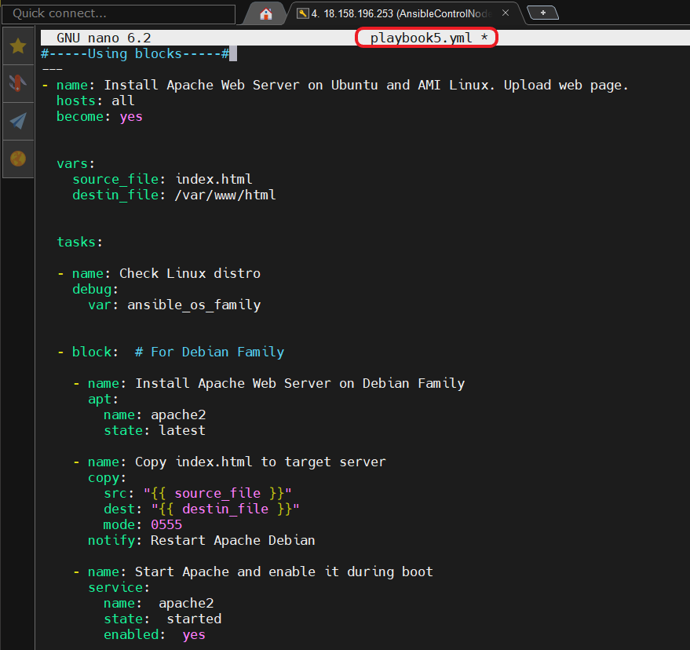

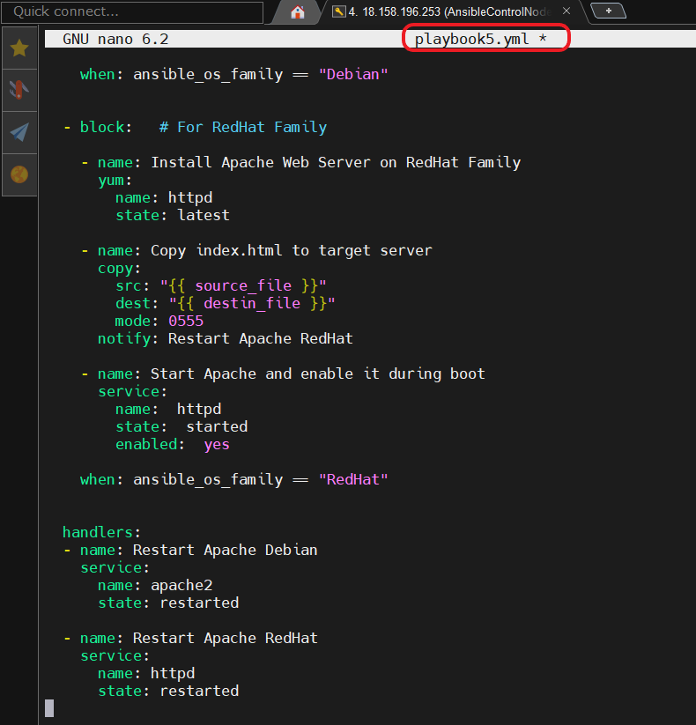

* Run **ansible-playbook** command.

$ ansible-playbook playbook5.yml

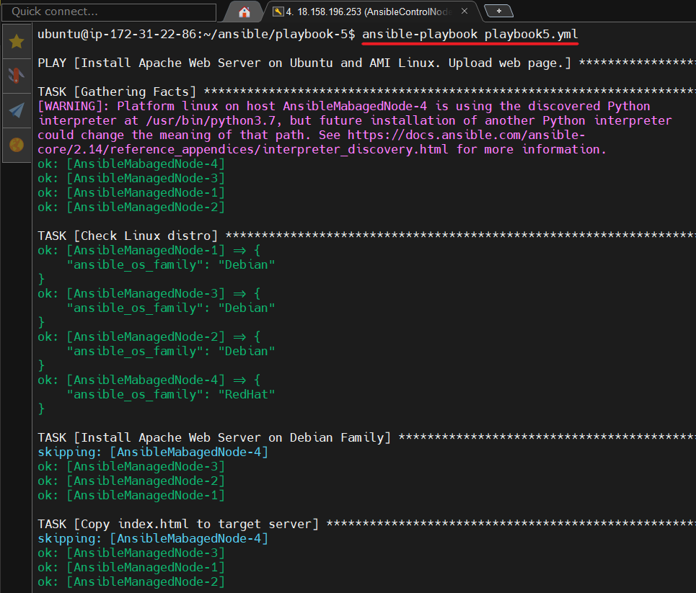

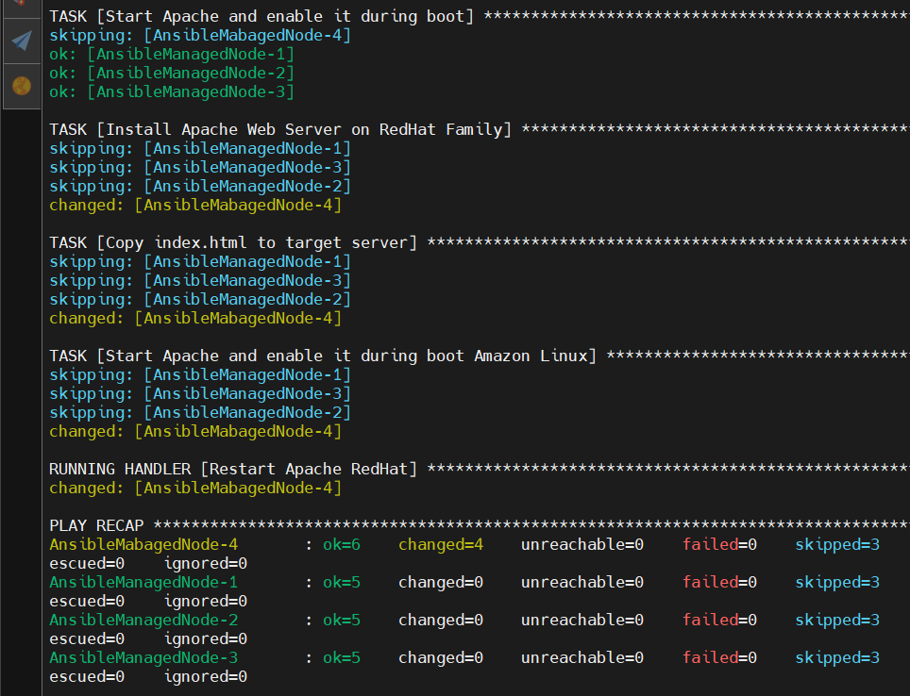

1. My sixth **Ansible** playbook. Loops.

**Task: Make some actions on remote server, results should be viewed by output console.**

* Creation file **playbook_loop1.yml**

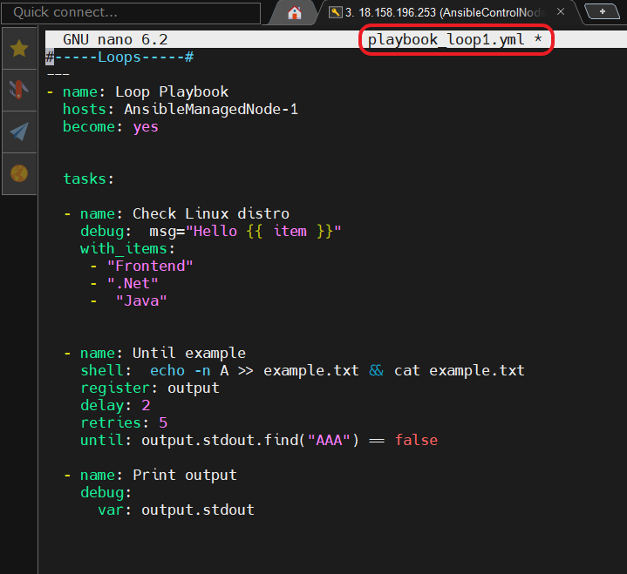

* Run **ansible-playbook** command.

$ ansible-playbook playbook_loop1.yml

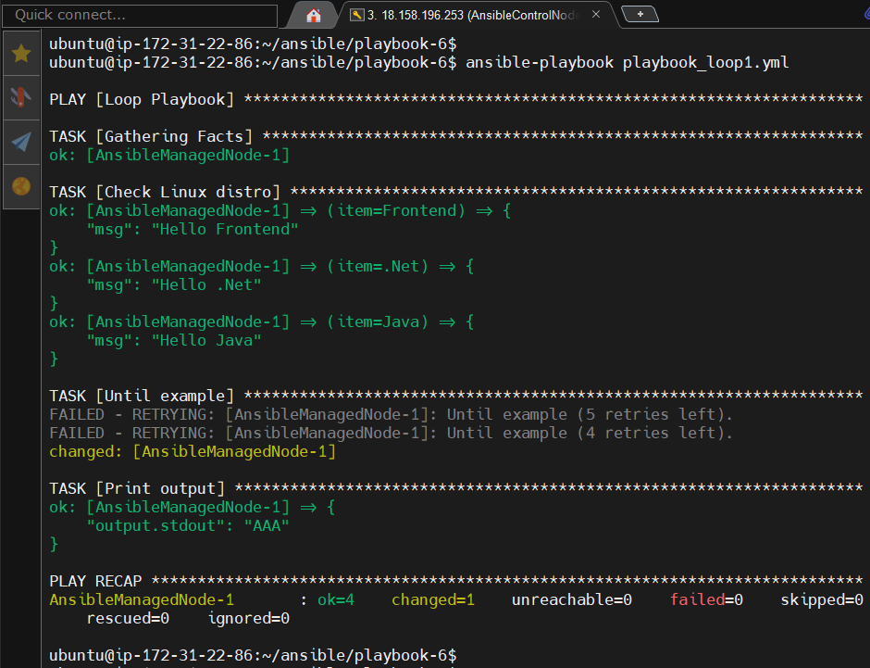

1. My seventh **Ansible** playbook. Loops2.

**Task: Copy WebPage (some files) to remote server using loop.**

* Creation file **playbook_loop2.yml**

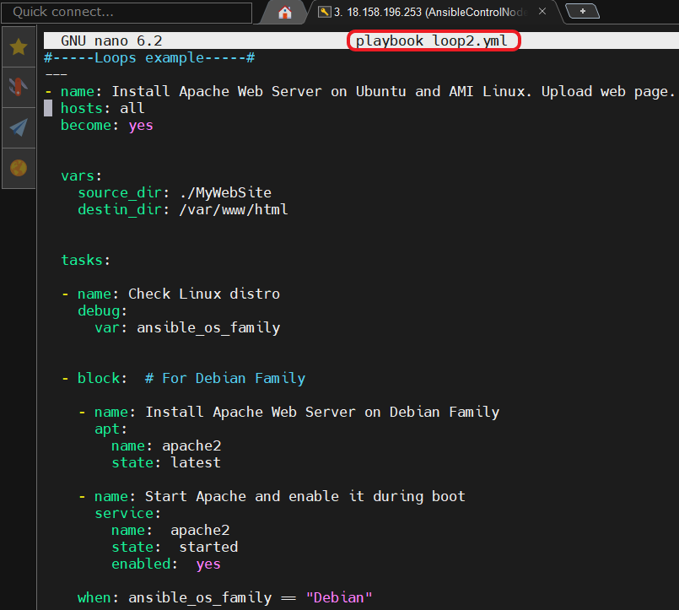

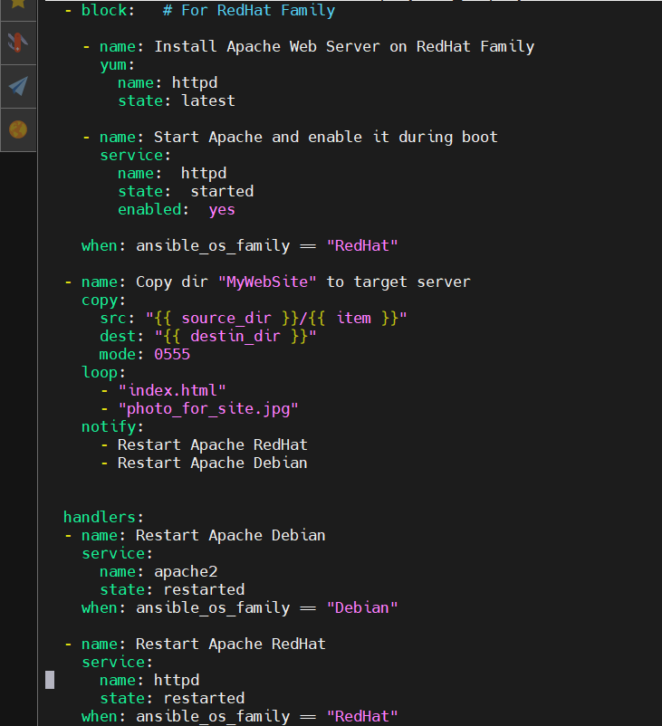

* Run **ansible-playbook** command.

$ ansible-playbook playbook_loop2.yml

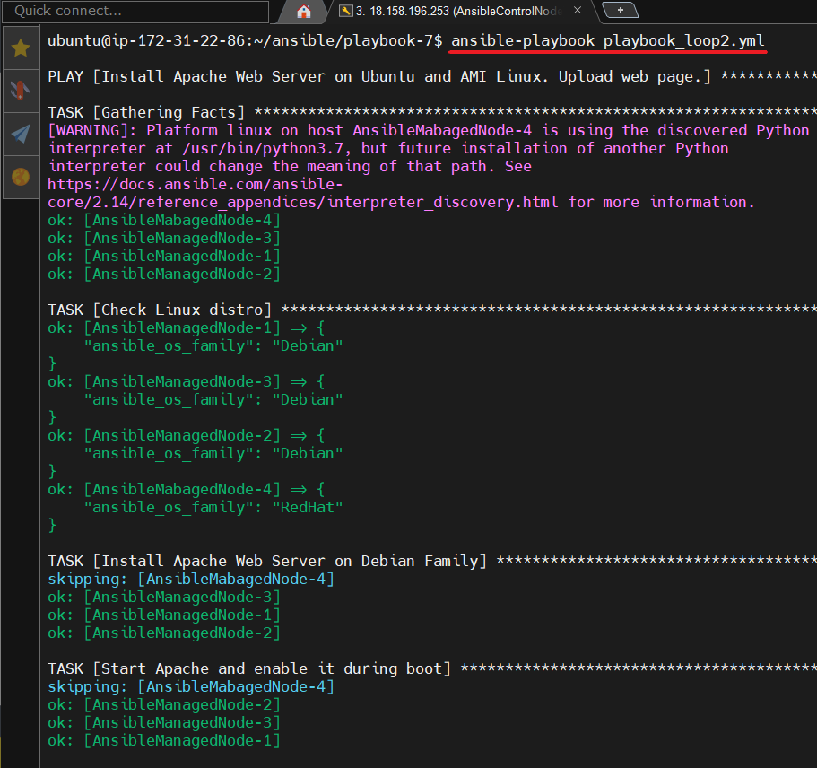

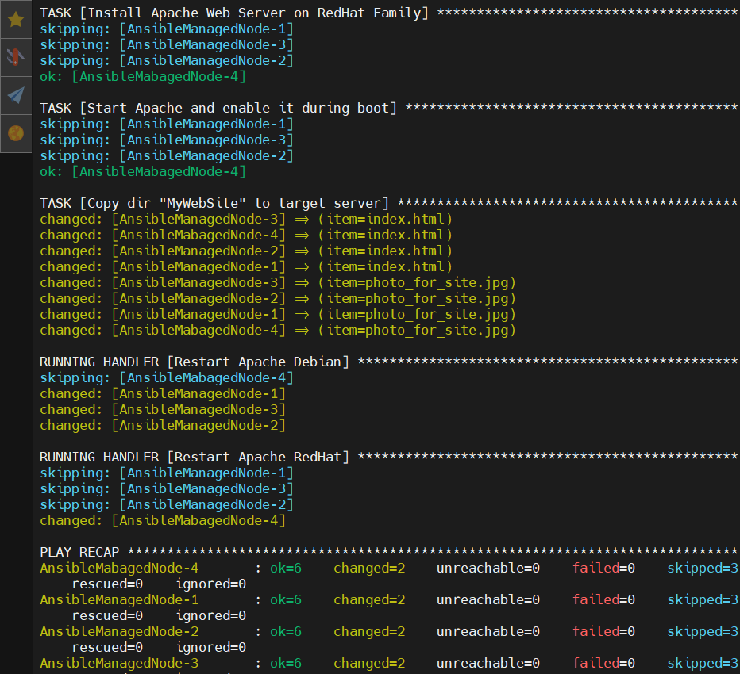

* Checking the availability of the **index.html** page on all Ansible Managed Node’s.

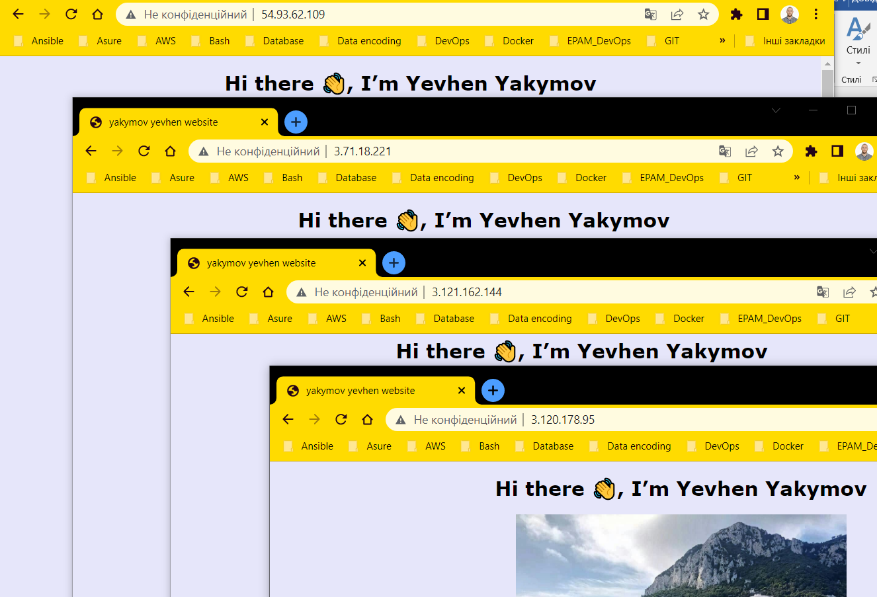

1. My eight **Ansible** playbook. Templates and Jinja.

**Task: Customize WebPage on remote servers using template and jinja.**

* Creation file **index.html.j2**

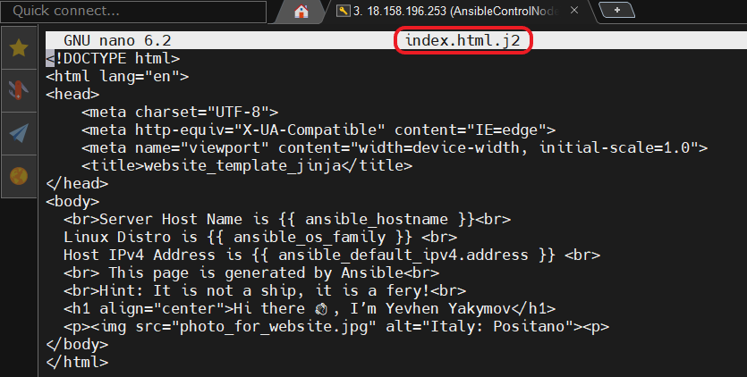

* Creation file **playbook6.yml**

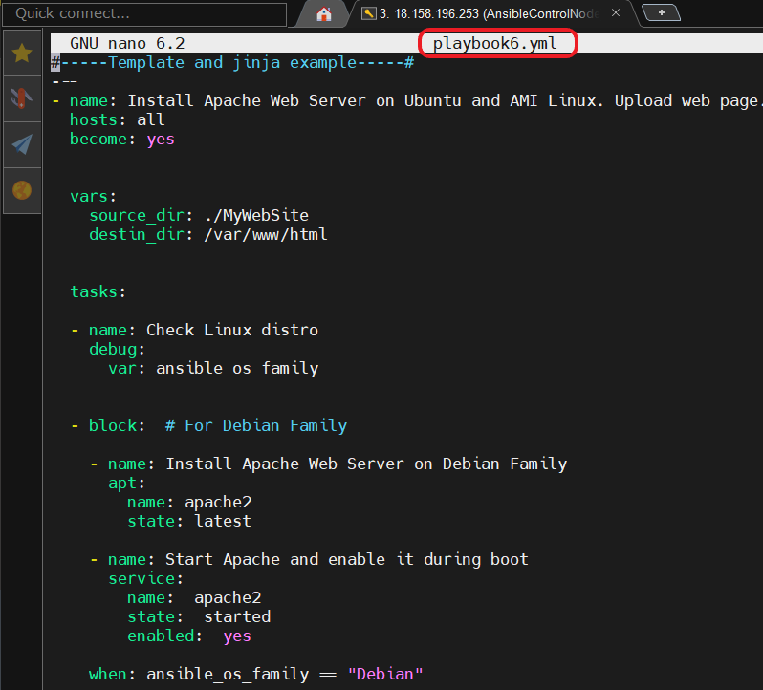

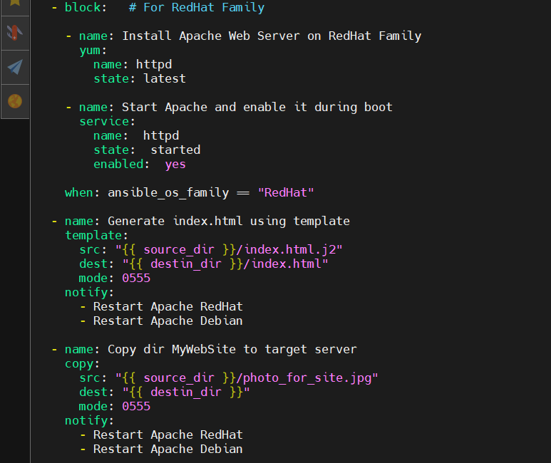

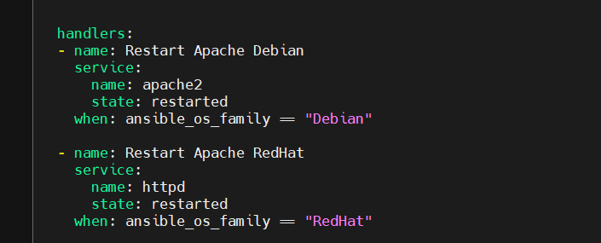

* Run **ansible-playbook** command.

$ ansible-playbook playbook6.yml

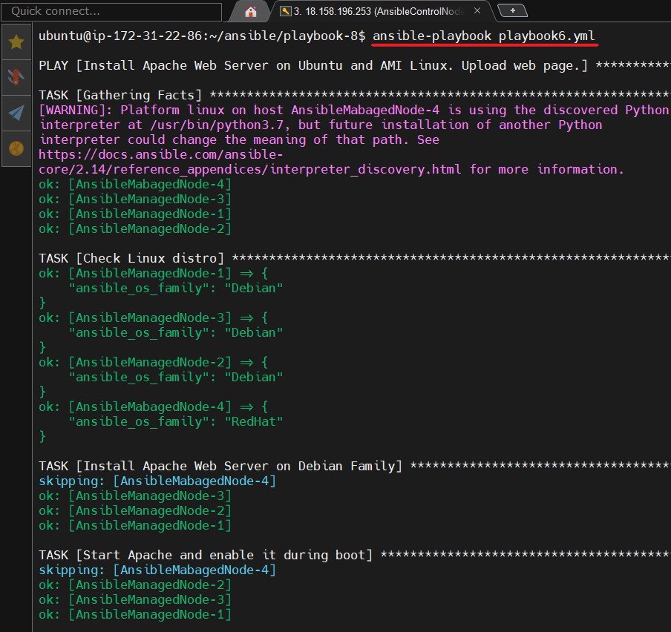

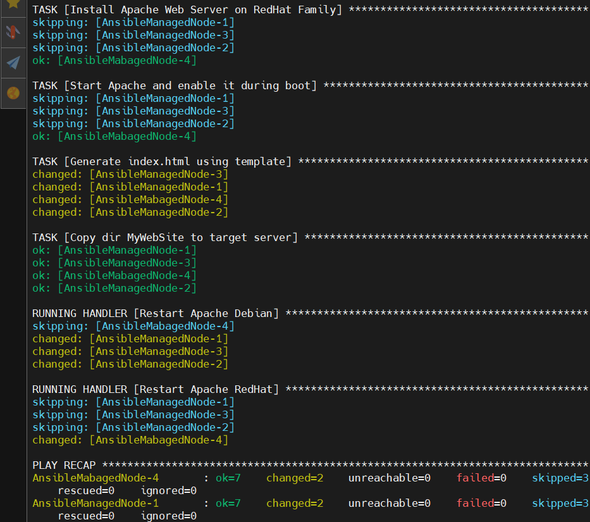

* Checking the availability of the **index.html** page on all Ansible Managed Node’s.

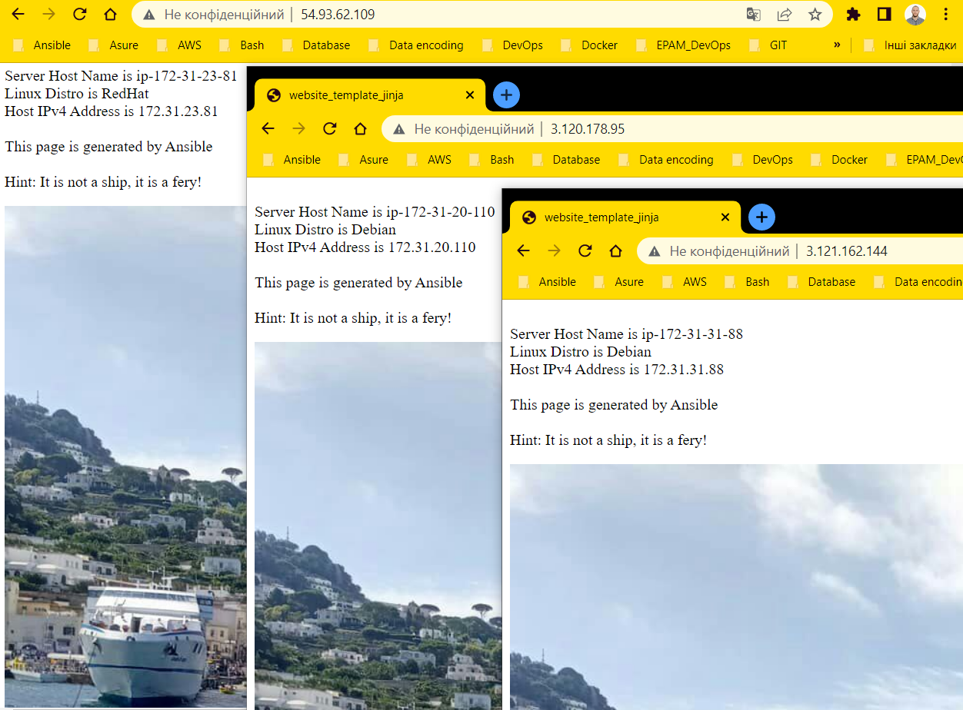

1. **Ansible** Roles.

**Task: modifying playbook_loop2.yml used ansible roles.**

* Creation **roles** directory and run **ansible** command

$ ansible-galaxy init depoloy-apache

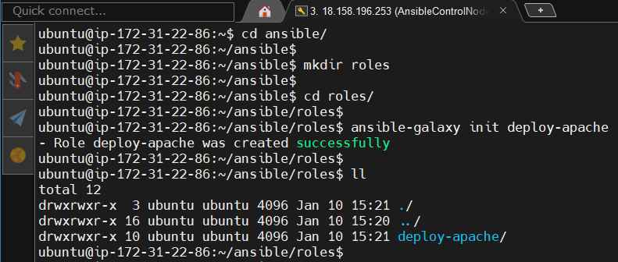

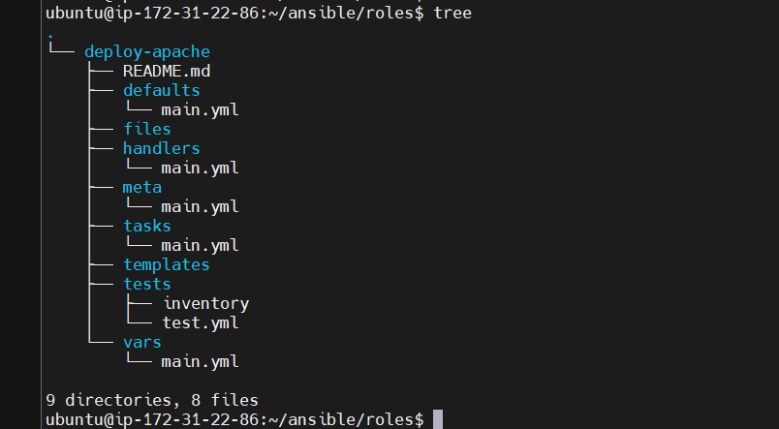

We have got the clean directory structure with the **ansible-galaxy** command. Each directory must contain a **main.yml** file, which contains the relevant content.

Where :

**tasks** – contains the main list of tasks to be executed by the role.

**handlers** – contains handlers, which may be used by this role or even anywhere outside this tole.

**defaults** – default variables for the role.

**vars** – other variables for the role. Var has the higher priority than defaults.

**files** – contains files required to transfer or deploy to the target machines via this role.

**templates** – contains templates which can be deployed via this role.

**meta** – defines some data / information about this role(author, dependency,versions, examples, etc).

* Writing variables to the **./roles/vars/main.yml** file

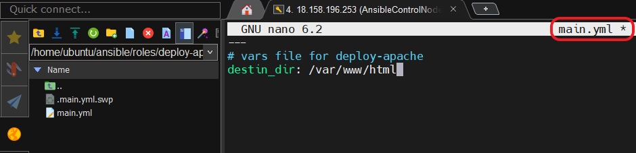

* Copy files that must be deployed to the **./roles/files/** directory

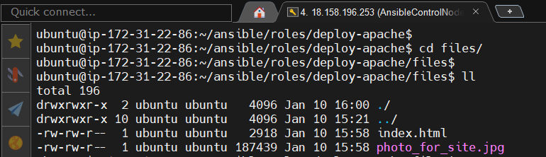

* Writing handlers to the **./roles/handlers/main.yml** file

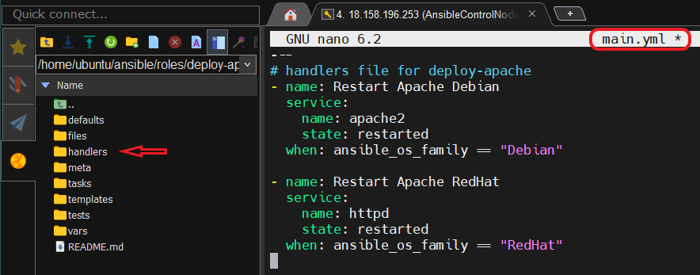

* Writing tasks to the **.roles/tasks/main.yml** file

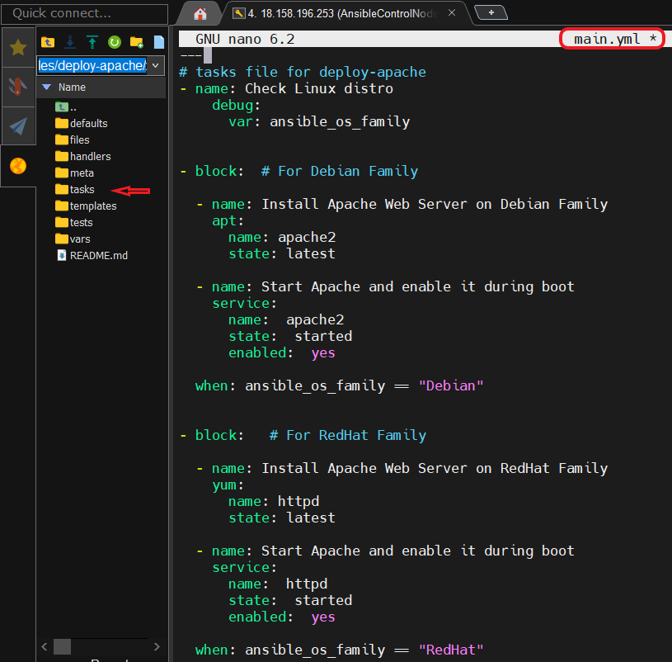

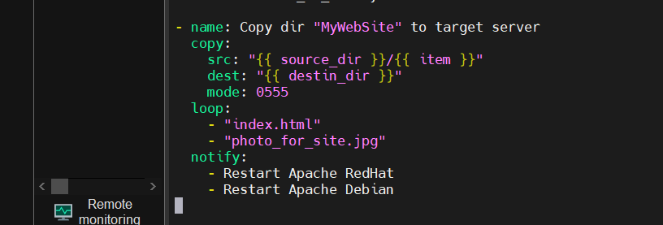

* Writing **playbook7.yml**

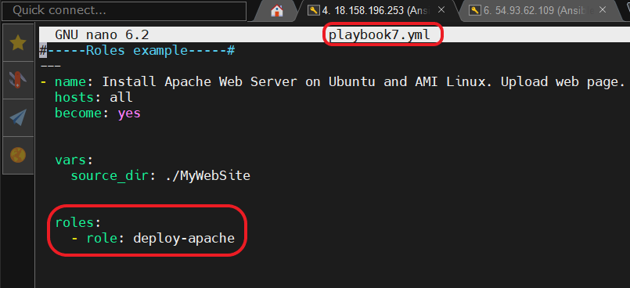

* Directory structure

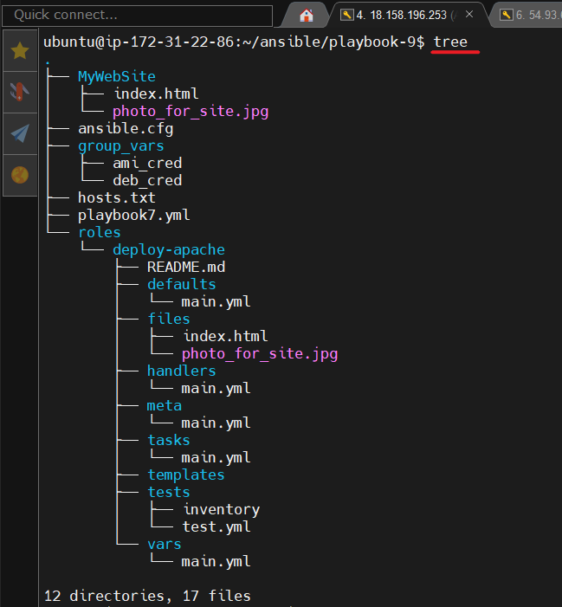

* Run **ansible-playbook** command.

$ ansible-playbook playbook7.yml

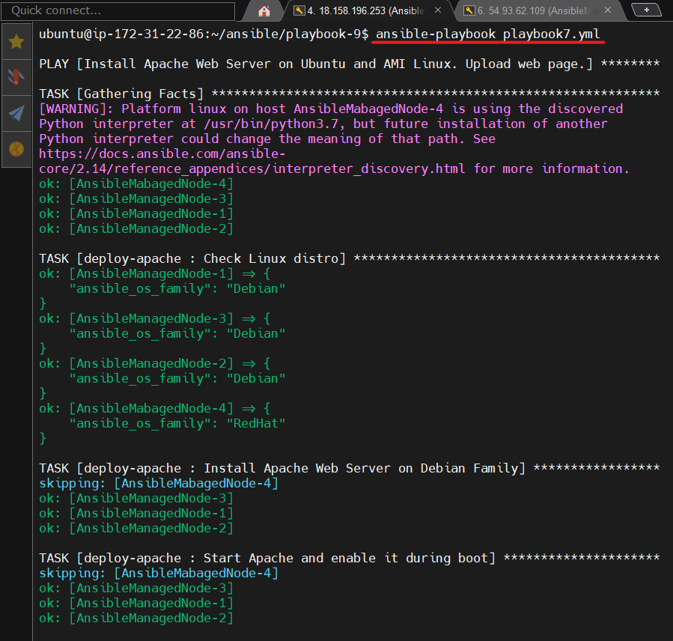

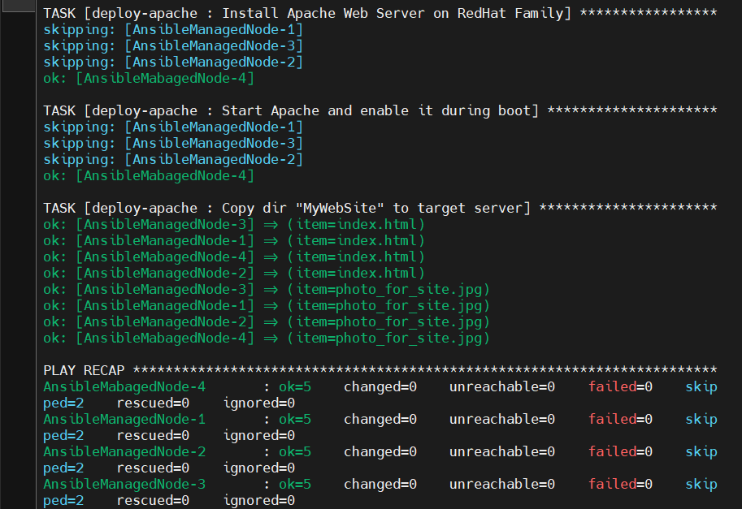

* Checking the availability of the **index.html** page on all Ansible Managed Node’s.



1. **Ansible**. Troubleshooting.

**The most common strategies for debugging Ansible playbooks are using the modules given bellow:**

* **Debug** and **Register**

These two are the modules available in Ansible. For debbuging purpose, we need to use the two modules judiciously.

* **Verbosity**

With the Ansible command, one can provide the verbosity level. You can run the commands with verbosity level one (-v), two (-vv) or three (-vvv)

* **--start-at-task and step mode**

When you are testing new plays or debugging playbooks, you may need to run the same play multiple times. To make this more efficient, Ansible offers two alternaative ways to execute a playbook: **start at task** and **step mode.**

To start executing your playbook at a particular task (usually the task that failed on the previous run), use **--start-at-task** option:

$ ansible-playbook playbook_name.yml –-start-at-task “Task_name”

To known list tasks of the current playbook, use **--list-tasks** option:

$ ansible-playbook playbook_name.yml –-list-tasks

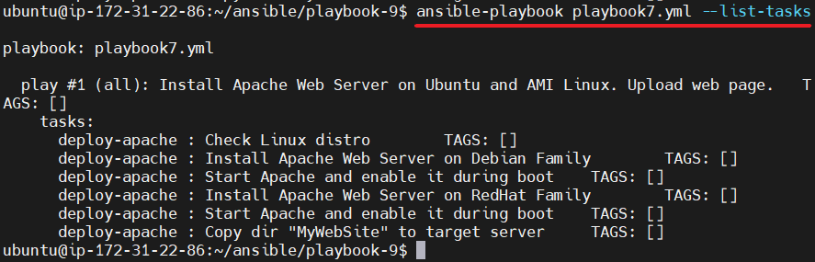

Very usefull approach to use in playbooks and roles **tag:**

tag:

* nginx

To execute a playbook interactively, use **--start-at-task** option:

$ ansible-playbook playbook_name.yml --step

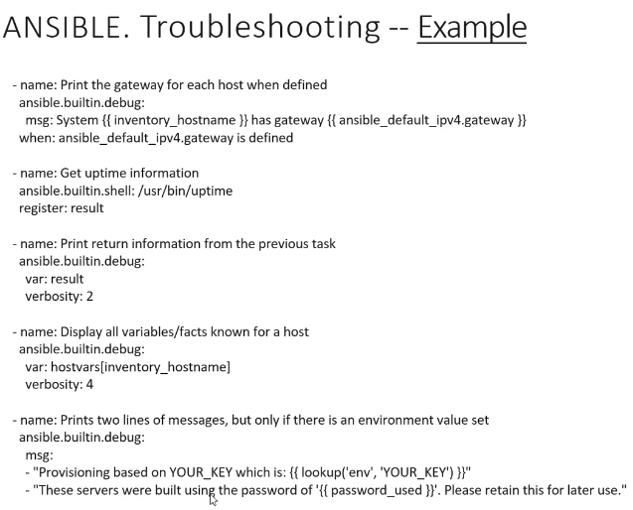

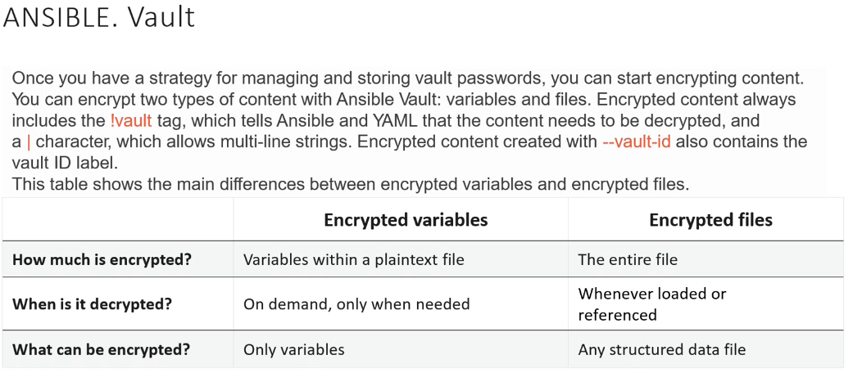

1. **Ansible**. Vault.

**Encrypting content with Ansible Vault:**

Ansible Vault encrypts variables and files so you can protect sensetive content sush as passwords or keys rather than leaving it visible as plainetext in playbooks or roles.

To use Ansible Vault you need one or more passwords to encrypt and decrypt content. If you store your vault passwords in a third-party tool such as a secret manager, you need a script to access them.

Use the password with the **ansible-vault** command-line tool to create and view encrypted variables, create encrypted files, encrypt existing files, or edit, re-key, or decrypt files. You can then place encrypted content under source control and share it more safely.

**Managing vault passwords:**

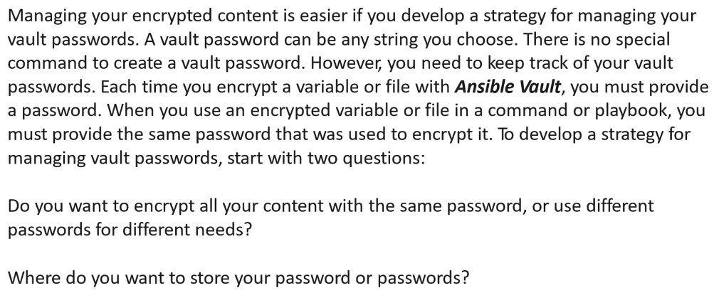

**Choosing between a single password and mulpiple passwords:**

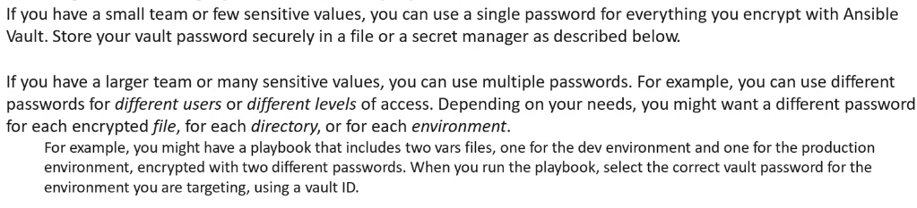

**Managing multiple passwords with vault ID’s:**

